NEWS RELEASE—For Immediate Release
Media Contact: Kelli Lane / 954-235-0331 / kellil@keiseruniversity.edu

Keiser University Honors Babu Thomas with an “Excellence in Forensic Science” Award
Faculty member has worked on over 10,000 cases and testified in more than 2,000 State and Federal court trials

Port St. Lucie, FL – June 30, 2014 –Keiser University hosted an event on Jun. 17 in honor of faculty member, Babu Thomas. Mr. Thomas has had an overwhelming impact on the criminal justice community, from an educator’s perspective, as well as his involvement in hundreds of investigations throughout the tri-county area. He has worked on easily more than 10,000 cases, has been a certified expert and testified in more than 2,000 State and Federal Court trials. He has been a teacher and lecturer at Florida Institute of Technology, Indian River State College and Keiser University. Also important to note, he has been published in the Journal of American Chemical Society, International Journal of Pure & Applied Chemistry, and the Journal of Chemical Physical Letters.

“Babu’s career has touched many of our lives as an educator and as a scientist within the crime lab, so it is only fitting we honor him for his more than 30 years of experience and contributions to the field of forensic investigations,” stated Derek Brieske, Forensics Program Coordinator.

The event allowed the invited guests who have known and worked with Thomas throughout the years to share stories of his influence before the ceremony where he was honored with the “Excellence in Forensic Science” award. This award will become an annual honor bestowed upon a student within the Forensic Investigation program who maintains a high GPA, is a leader within their class and the community, and goes above and beyond their own program to help shape the future of the field of forensics. Current student Celeste Brown was surprised to be named the first recipient of the award.

# # #

About Keiser University: Keiser University is a private, not-for-profit university serving nearly 20,000 students pursuing doctoral through associate degrees on 17 campuses, online and internationally, employing 3,500 staff and faculty.

Sixty-two percent of KU students graduate in STEM (Science, Technology, Engineering and Math) and health care fields, providing the talented workforce necessary for Florida to compete globally.

Keiser University is accredited by the Commission on Colleges of the Southern Association of Colleges and Schools to award certificates and degrees at the associate, baccalaureate, masters, and doctoral levels. Contact the Commission on Colleges at 1866 Southern Lane, Decatur, Georgia 30033-4097 or call 404-679-4500 for questions about the accreditation of Keiser University.
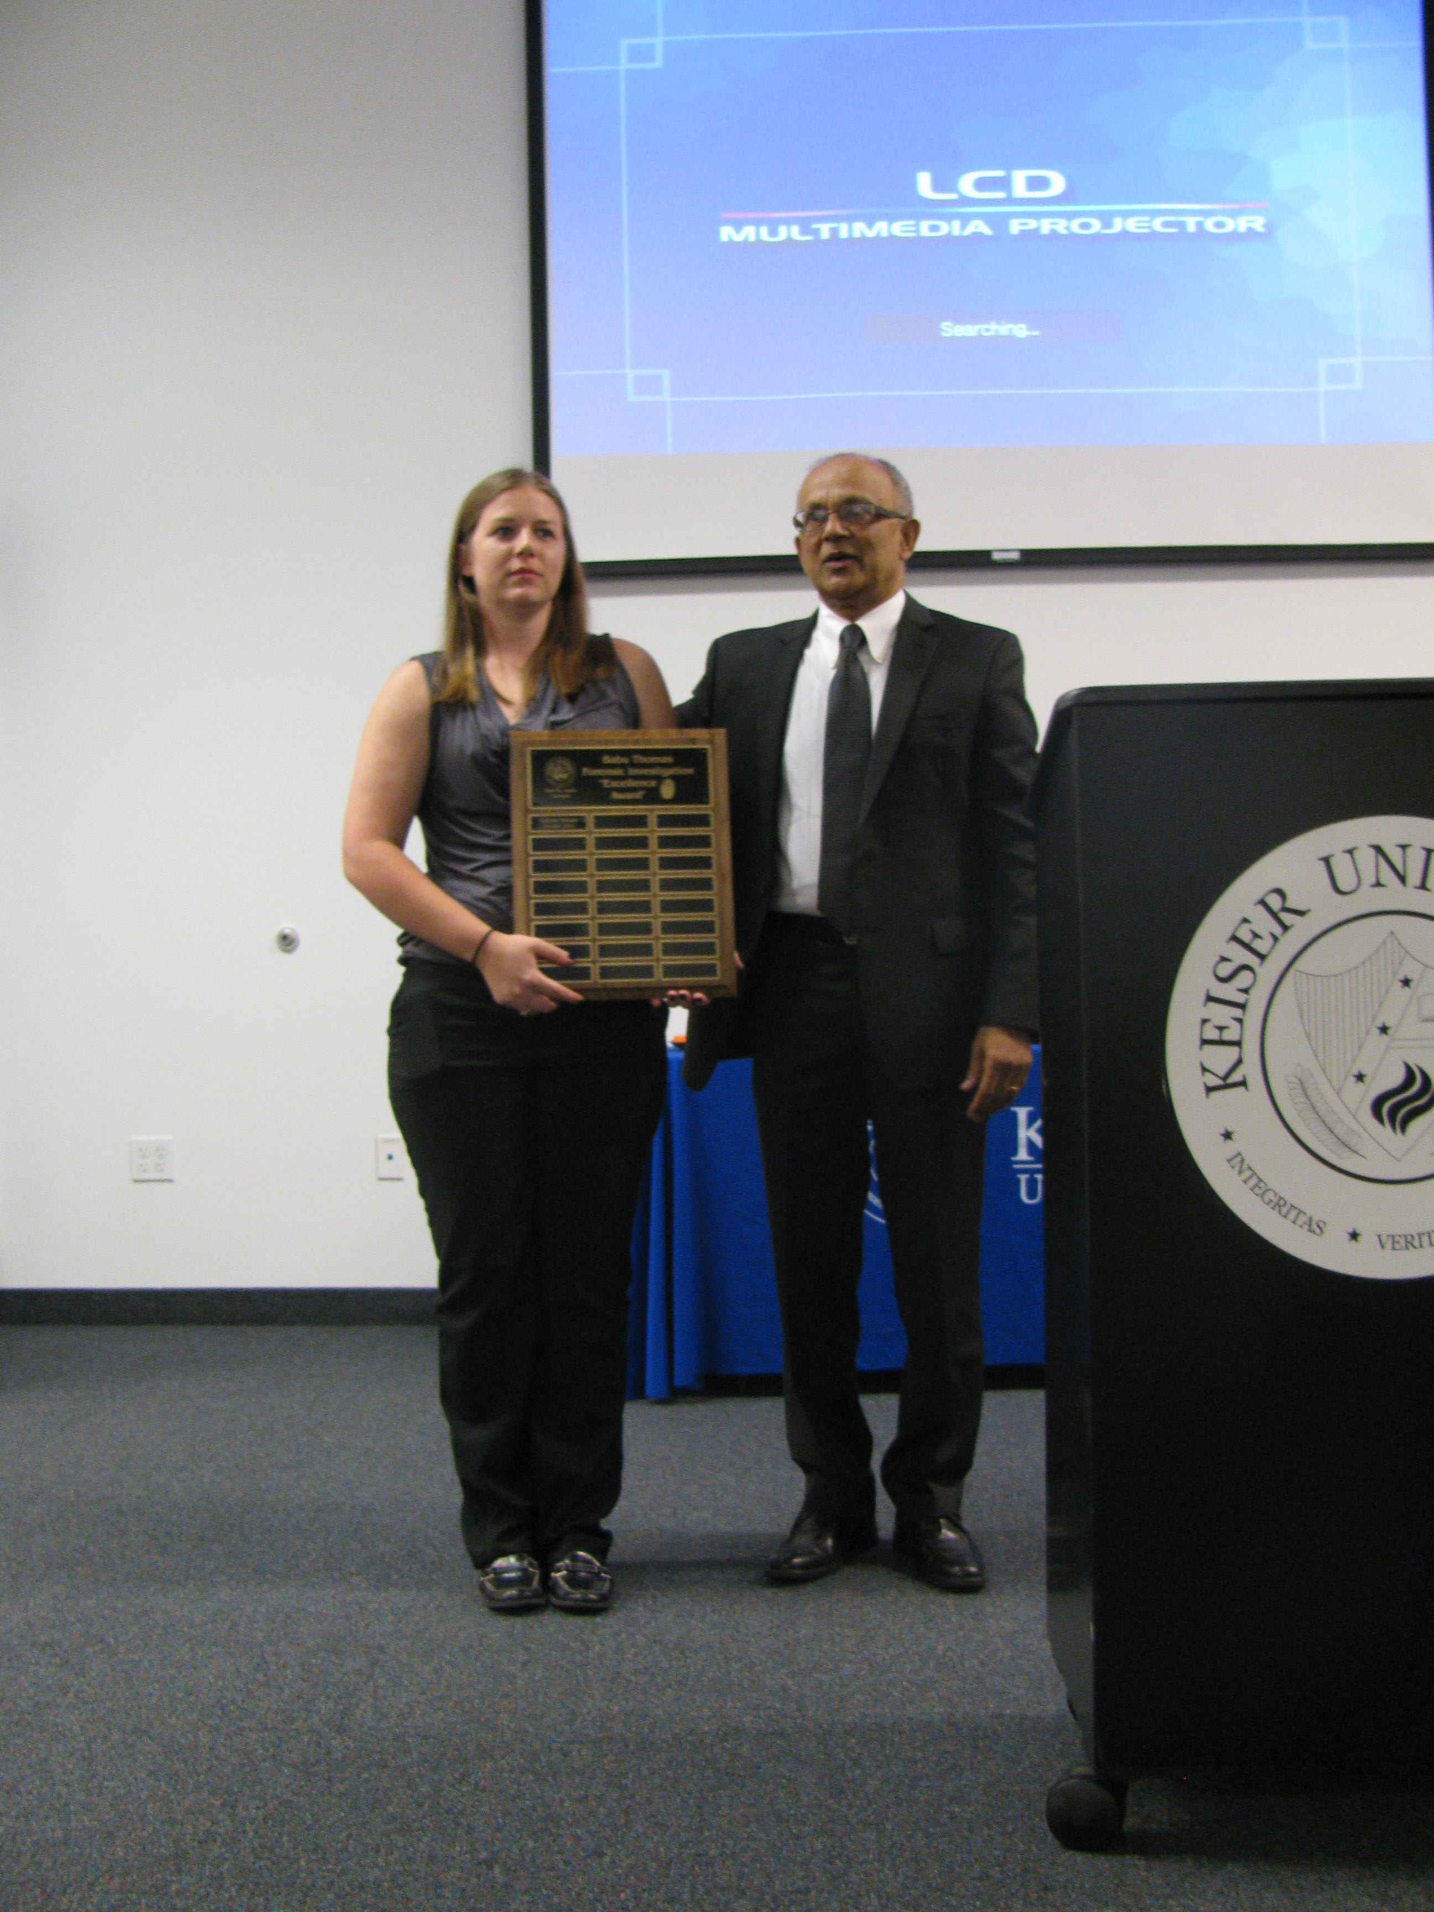
Keiser University student Celeste Brown is presented the Babu Thomas Excellence in Forensics Award by Forensics Instructor Babu Thomas.

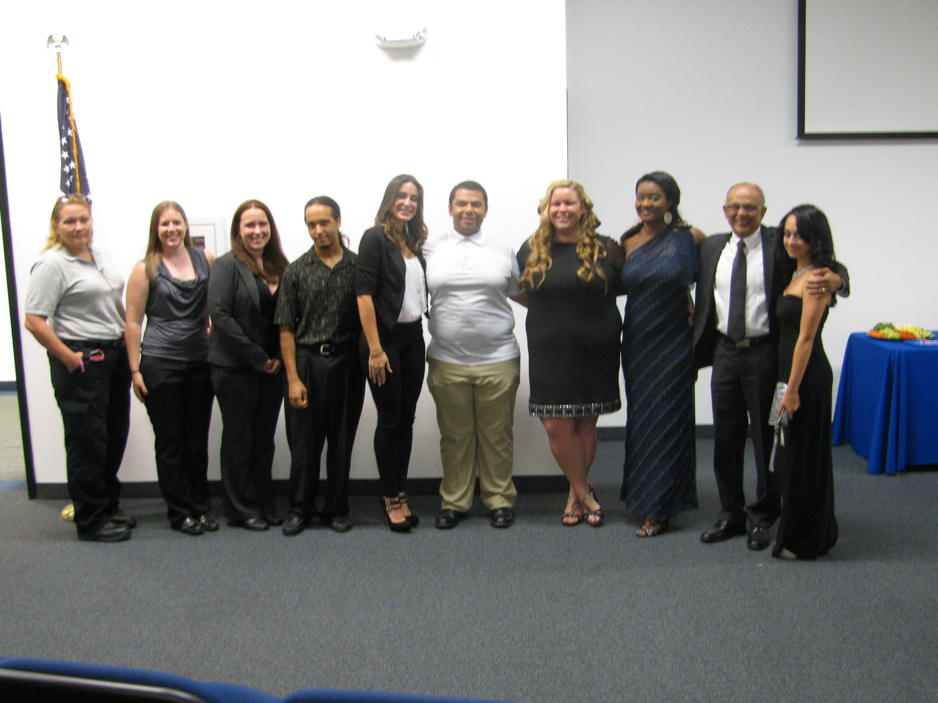
Current Keiser University students and graduates of the Forensic Investigation degree program gather with instructor Babu Thomas who stated in the award ceremony that his students were one of his favorite accomplishments.

