NEWS RELEASE – Immediate Release
Contact: Kelli Lane / 954-235-0331 / kellil@keiseruniversity.edu

Keiser University Receives “Congressional Medal of Honor Partnership Award”
The local chapter of the Vietnam Veterans Association made the presentation

*Photo as .jpeg attachment available on request.

Port St. Lucie, FL –Sept. 29, 2014—Members of the Vietnam Veterans of America, Chapter #566 of Port St. Lucie, presented Keiser University’s Port St. Lucie campus with their highest award, “The Congressional Medal Of Honor Partnership Citation”. This great honor is in recognition of the active partnership and support the campus has provided the group over the years.
“This is an incredible gift the Vietnam Veterans of America have chosen to bestow the campus with and we were delighted to learn from the President of the club that we were the only university in the state chosen for this distinction,” stated Dr. Jan Del Signore, MSGT, USAF Retired and Associate Vice Chancellor of Military Affairs. The Port St. Lucie Campus has a Student Veterans of America chapter that has worked closely with the Vietnam Veterans of America since 2010.
This artwork depicts each war our country has ever engaged in and has been signed by fourteen Congressional Medal of Honor recipients, who fought in three separate wars. One of the Congressional Medal of Honor recipients, Col. Bruce Crandall, was a helicopter pilot in the Vietnam War and was responsible for leading the very first air mobile operations at the start of the war and completed over 900 combat missions by the end. He is considered a pioneer of helicopter warfare and a legend in Army aviation. This very operation was the inspiration for the movie “We Were Soldiers” starring Mel Gibson.
About Keiser University: Keiser University is a private, not-for-profit university serving nearly 20,000 students pursuing doctoral through associate degrees on 17 campuses, online and internationally, employing 3,500 staff and faculty. Sixty-two percent of KU students graduate in STEM (Science, Technology, Engineering and Math) and healthcare fields, providing the talented workforce necessary for Florida to compete globally.

Keiser University is accredited by the Commission on Colleges of the Southern Association of Colleges and Schools to award certificates and degrees at the associate, baccalaureate, masters, and doctoral levels. Contact the Commission on Colleges at 1866 Southern Lane, Decatur, Georgia 30033-4097 or call 404-679-4500 for questions about the accreditation of Keiser University.

# # #

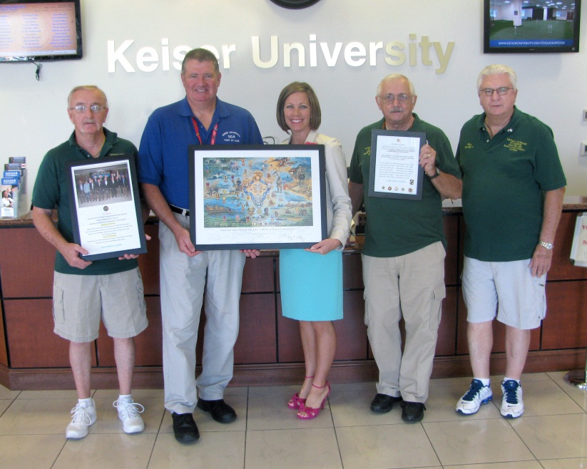
Pictured left to right: Mike Bradley, John Hooker (Student Services Director), Dr. Michele Morgan (Associate Vice Chancellor), Joseph Lusardi, and Roy Brewer

