Spooky storybook hour brings together families and Halloween fun
By Eli Vera - South Florida News Service
10/23/2014 12:47 PM / Updated: 10/23/2014 1:37 PM
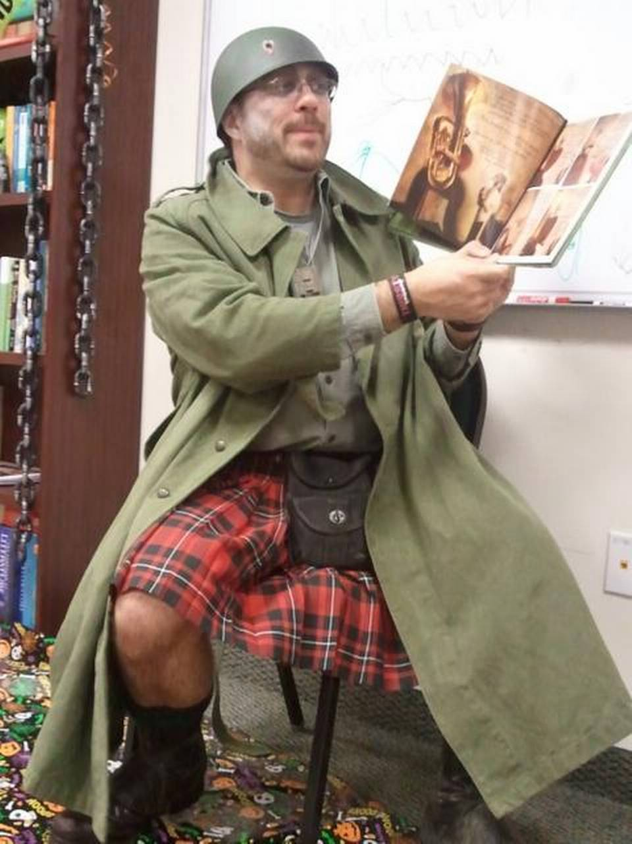
STORYTELLER: Aragorn Vitali, 43, reads “The Wolves in the Walls” by Neil Gaiman at the Second Annual Spooky Storybook Hour at Keiser University in Miami. The event will take place from 6:30 p.m. to 7:30 p.m. Thursday at Keiser University, 2101 NW 117th Ave.

For Sylvanna Vitali, reading with her father every night before going to sleep is a vivid childhood memory.
“He [father] would do all the different voices, the dramatic pauses and go all out,” said Vitali, 11, a sixth grader at Gulliver Academy in Coral Gables. “I really enjoyed the theatrical element he would put into it.”
Today, Sylvanna’s father, Aragorn Vitali, 43, still finds time to bond with his daughter through literary activities.
“It’s always fun to read books in front of an audience,” said Vitali. “Reading is such a wealth of knowledge and experience.”
On Oct. 29, Vitali will be one of 12 parents volunteering at The Annual Spooky Storybook Hour, where community members read to children in a storytelling-style, emphasizing characterization, sounds and visuals.
The “3rd Annual Spooky Storybook Hour” is a free family-oriented event for children ages 2 to 10. It will take place from 6:30 p.m. to 7:30 p.m. Thursday at Keiser University, 2101 NW 117th Ave.
“Halloween and storytelling go hand in hand,” said Belkis Cabrera, 39, founder and coordinator of the event. “Whenever I think of Halloween, I think of the traditional campfire spooky story with the flashlight image.”
Cabrera, who taught literature for more than 10 years, aims to preserve the tradition of reading to the young ones.
“The younger you get them hooked, the easier it is to maintain that spirit, spark and interest,” said Cabrera, writing coordinator at Keiser University.
This year, the event will feature three books recommended by parents and teachers: “Creepy Carrots!” by Aaron Reynolds; “Boris and Bella” by Carolyn Crimi; and “Humbug Witch” by Lorna Balian. The books explore picture description, drawing inferences and identifying sounds.
Experts say engaging in storytelling activities enriches parent-child relationships.
“On a cognitive level, the child is acquiring knowledge both visually and in a participatory way,” said Gloria Lopez, 64, psychologist and guidance counselor at Marcus A. Milam Center in Hialeah. “Emotionally, it strengthens the relationship between the parent and the child, to share and create something together through storytelling is excellent.”
Sara de la Noval, who shares her love for books with her son Sebastian, 9, plans to attend.
“I’ve read books to him since he was a baby,” said de la Noval, a stay-at-home mother from Westchester. “Any type of activity where he can learn, have fun and interact with books, I think it’s great.”
At the end of the event, children can join “The Skeleton Dance,” a Halloween music video choreography, and participate in a book raffle, where 20 books will be given away.
“I want kids to walk out with a book in their hands and treat it as if it was candy,” said Cabrera.
If you go
What: 3rd Annual Spooky Storybook Hour
Where: Keiser University Writing Studio, 2101 NW 117th Ave.
When: 6:30 p.m. to 7:30 p.m. Oct. 29
Cost: Free
For information, contact Belkis Cabrera at: bcabrera@keiseruniversity.edu or call 305-596-2226 ext.111

