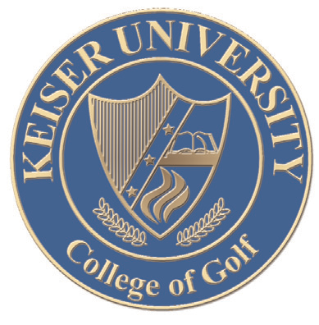NEWS RELEASE
Media Contact: Kelli Lane,
kellil@keiseruniversity.edu
Keiser University College of Golf & Sport Management Teams Up with PACE Center for Girls

Keiser University students hold a ‘Friends-Raiser’ to demonstrate support for young girls in the community

PORT ST. LUCIE, Fla. — Keiser University College of Golf & Sport Management (COGSM) teamed up with the PACE (Practical Academic Cultural Education) Center for Girls to help increase public awareness for the issues and challenges faced by girls and young women. The Keiser University COGSM recently hosted a ‘Friends- Raiser’ with a variety of indoor golf events and contests that delighted golfers of all skill levels and donated all proceeds to benefit the lives of PACE girls.

The Saturday morning event featured three-hole putting contest, closest-to-the-pin contest, longest drive and many other activities. Guests also enjoyed golf history displays, wellness clinics, chair massages, breakfast and fun raffles.

“We had a tremendous turnout and our 5,000-square-foot indoor practice facility was filled to capacity,” says John McMurry, Vice President of Keiser University College of Golf & Sport Management. “Girls and young women face a set of unique issues and challenges in our society, and we are already planning for another PACE event for 2016 to help meet those challenges. As both a game and an industry, golf provides a wide variety of opportunities and life lessons which can help teach and inspire girls and young women to achieve great suc- cess.”

PACE is a not-for-profit 501(c)3 organization that provides a non-residential delinquency prevention program that targets the unique needs of females 12- to 18-years-old who are identified as dependent, truant, runaway, delin- quent, or in need of academic skills. Established 30 years ago in Jacksonville, Fla., to help 10 girls, PACE now includes 17 centers throughout Florida that serve more than 2,000 girls every year and has helped more than 21,000 girls since 1985. For more information about PACE, visit www.pacecenter.org

“The collaboration between the PACE Center and Keiser University was an obvious and natural choice,” says Vickie Colter, executive director for the PACE Center for Girls. “Keiser obviously cares about their students and understands that our girls are going to graduate high school and need to be exposed to all kinds of secondary education. And they need to see that girls can definitely play golf too!”

The Keiser University COGSM degree in Golf Management prepares students for a wide variety of positions in the golf industry. The program gives students the educational background and training to provide golf instruction, manage golf course operations, ensure proper maintenance of golf facilities and equipment, as well as how to incorporate the play of golf into the broader hospitality and recreation domain. Keiser University COGSM's Bachelor of Science in Sport Management degree (with a concentration in golf management) focuses on the

managerial and business aspects of a career in golf. The curriculum supports an expanded professional role of sports managers and graduates of associate degree programs in golf, hospitality, fitness, sports, recreation and other related fields.

For more information on attending Keiser University College of Golf & Sport Management, please contact the College of Golf campus at 1860 Fountainview Blvd, Port St. Lucie, Fla.; online at www.CollegeofGolf.KeiserUniversity.edu; or call 888.355.4465.

About Keiser University:
Keiser University is a private, not-for-profit university serving nearly 20,000 students pursuing doctoral through associate degrees on 17 campuses, online and internationally, employing 3,500 staff and faculty. Keiser University holds Level VI accreditation signifying recognition of its expanded doctoral degree offerings. Sixty-two percent of KU students graduate in STEM (Science, Technology, Engineering and Math) and healthcare fields, providing the talented workforce necessary for Florida to compete globally. Over 20 percent of Keiser University students are members of the armed services, veterans, or military family members. Keiser University is accredit- ed by the Southern Association of Colleges and Schools Commission on Colleges to award certificates and degrees at the associate, baccalaureate, masters, specialist, and doctoral levels. Contact the Commission on Colleges at 1866 Southern Lane, Decatur, Georgia 30033-4097 or call 404.679.4500 for questions about the accreditation of Keiser University.

— 30 —

