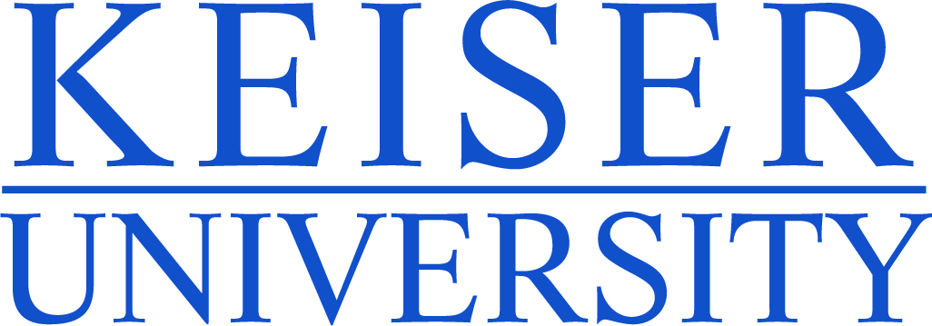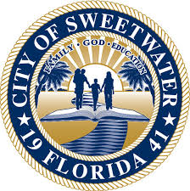

NEWS RELEASE – Immediate Release
Contact:
Kimberly Dale / Keiser University / 954-849-5304 / kdale@keiseruniversity.edu
Robert Herrada / Senior Center Director / 305-525-0594 / rherrada@cityofsweetwater.fl.gov

Keiser University Creates a Partnership with the City of Sweetwater
Keiser University students will be at the Claude and Mildred Pepper Senior Activities Center to provide valuable services

Miami, FL—March 23, 2015 —Keiser University’s Miami campus has forged a new partnership with the City of Sweetwater to assist the City’s vibrant Mildred and Claude Pepper Senior Activities Center. Students from five different degree programs will visit the center located at 10600 SW 4th Street, Sweetwater on Thursday, March 26, 2015 from 9:00 a.m. to 11:00 a.m. to showcase their weekly activities provided to over 100 senior citizens within the city limits. City and university officials will be present to see the benefits of the direct interaction between the residents of Sweetwater and Keiser University (KU) students.

As a result of a dialogue between Keiser University and Sweetwater Mayor Jose M. Diaz, it was determined there were mutual needs that could be met by creating this partnership. Keiser students will benefit from the opportunity to practice the skills learned in the classroom setting and the seniors will have the chance to receive services and presentations from students and faculty. The degree programs represented by students on March 26 will be Occupational Therapy Assistant - working on arts and crafts which promote the maintenance of cognitive and motor function; Nursing – providing blood pressure screening and education on hypertension diet, diabetic diet, diabetic foot care and home safety; Sports Medicine & Fitness Technology- leading group exercises to improved balance, flexibility, blood pressure regulation, and cognition; Psychology - leading structured group activities to improve memory; and Radiological Technology - promoting cognitive engagement through positive verbal interactions between students and seniors.

“The City of Sweetwater has been an exceptional partner since our campus moved to this location so having the ability to work together on something benefitting our students and the citizens of this area has a positive ripple effect,” said Dr. Gary Markowitz, Campus President. “Keiser University has been in the Miami area since 2001 and moved to this location in 2011.”

The university has participated in a variety of city events including monthly food packing and distribution events to help the residents that are in need of food and assistance. KU Miami was actively involved in the Thanksgiving and Christmas food drives as well as in their senior center Christmas luncheon put together by Mayor Jose Diaz and his staff. Mayor Diaz commented, “I am honored that Keiser University and Dr. Markowitz have chosen to manifest their commitment to the community through implementing this programming that drastically improves the quality of life to our City’s seniors. This exemplifies the great results that can be yielded when an institution of higher learning and local government partner to positively impact and augment a community’s well-being.” Students also volunteered at the Valentine’s Day lunch held at a ranch in South Dade. Keiser University has also established a scholarship program for the employees of the City of Sweetwater to assist in the Mayor’s plan for using education to help build professionals and leaders within the City.

About Keiser University: Keiser University is a private, not-for-profit university serving nearly 20,000 students pursuing doctoral through associate degrees on 17 campuses, online and internationally, employing 3,500 staff and faculty. Keiser University holds Level VI accreditation signifying recognition of its expanded doctoral degree offerings.
Sixty-two percent of KU students graduate in STEM (Science, Technology, Engineering and Math) and healthcare fields, providing the talented workforce necessary for Florida to compete globally. Over 20 percent of Keiser University students are members of the armed services, veterans, or military family members.
Keiser University is accredited by the Southern Association of Colleges and Schools Commission on Colleges to award certificates and degrees at the associate, baccalaureate, masters, specialist, and doctoral levels. Contact the Commission on Colleges at 1866 Southern Lane, Decatur, Georgia 30033-4097 or call 404-679-4500 for questions about the accreditation of Keiser University.
# # #

