K E I S E R
UNIVERSITY
News Release—For Immediate Release
Media Contact: Kimberly Dale / 954-849-5304 / kdale@keiseruniversity.edu

Keiser University’s College of Golf and Sport Management Partners with Wounded Warrior Project
Keiser University works to develop a program to introduce veterans to golf

Port St. Lucie, FL—April 2015— Keiser University’s College of Golf and Sport Management was pleased to welcome Mr. William Hannigan, Physical health & Wellness Specialist and Coordinator for the Wounded Warrior Project (WWP) to the campus. He brought his service dog, Pepa, and they toured the campus and visited with students, faculty and staff.

Keiser University (KU) and the Wounded Warrior Project are working together to develop a new pilot program to introduce WWP veterans to the game of golf. The golf students will volunteer their time and service to offer hands-on instruction, education, and playing lessons to the WWP veterans.

“We will also explore opportunities to provide some adaptive golf lessons for interested WWP veterans,” said John McMurry, Campus Vice President. “During the visit it was discussed how golf can serve veterans in so many ways as they transition back into their communities and day to day lives.”

About Keiser University:

Keiser University is a private, not-for-profit University serving nearly 20,000 students offering 100 degrees at the doctoral through associate level on 17 Florida campuses, online and internationally, employing 3,500 staff and faculty. Keiser University holds Level VI accreditation signifying recognition of its expanded doctoral degree offerings.

Sixty-two percent of KU students graduate in STEM (Science, Technology, Engineering and Math) and healthcare fields, providing the talented workforce necessary for Florida to compete globally. Statewide Keiser University campuses currently have 60 accredited programs, spanning 21 program offerings, from 18 accrediting agencies/regulatory agencies to ensure that the top industry standards are met in degrees such as nursing, occupational therapy assistant, radiologic technology, physical therapy assistant, physician’s assistant, and many others.

Keiser University is accredited by the Southern Association of Colleges and Schools Commission on Colleges to award certificates and degrees at the associate, baccalaureate, masters, specialist, and doctoral levels. Contact the Commission on Colleges at 1866 Southern Lane, Decatur, Georgia 30033-4097 or call 404-679-4500 for questions about the accreditation of Keiser University.

For additional information regarding Keiser University, go to www.keiseruniversity.edu

###
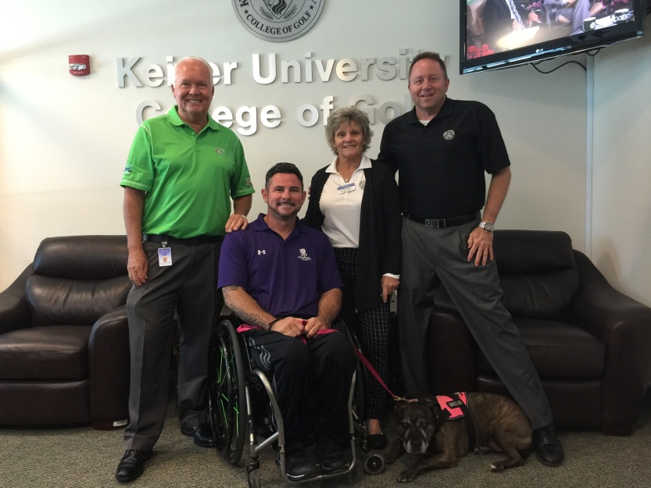
L-R: Dr. Eric Wilson, Executive Director of Golf; William Hannigan, the Physical Health & Wellness Specialist and Coordinator for the Wounded Warrior Project; Donna White, COGSM LPGA Faculty Member and 2015 LPGA Hall of Fame Inductee; John McMurry, Campus Vice President

