NEWS RELEASE--Immediate Release
Contact: Kimberly Dale / 954-849-5304 / kdale@keiseruniversity.edu

Keiser University’s Sarasota Campus Expects 326 Graduates for Summer Commencement
Sharon Hillstrom, President & CEO of Bradenton Area EDC, will serve as the keynote speaker

Sarasota, FL—May 2015—Keiser University faculty and staff of the Sarasota campus, join in celebration with the family and friends of the more than 320 graduates who will be attending their commencement ceremony on Friday, May 15. The ceremony will take place at 7:00 p.m. at the Bradenton Area Convention Center, which is located at One Haben Blvd. in Palmetto. The keynote speaker for this graduating class will be Sharon Hillstrom, President and CEO of the Bradenton Area Economic Development Corporation.

This spring, close to 5,400 Keiser University graduates are expected to cross stages throughout the state signifying completion of their college degrees and the beginning of the next chapter in their professional lives. Crossing the stage in Sarasota as the valedictorian will be Stacy Forehand who is graduating with an Associate and a Bachelor’s degree. She earned her AA in Paralegal Studies and her BA in Legal Studies. The salutatorian for this class will be Lisa Perry who earned her Bachelor of Science degree in Nursing.

“Graduation day is a time to reflect on all the hard work and accomplishments of our graduates and to recognize sacrifices that not only they made but the sacrifices their families made as well. The ceremony is a celebration of their achievements and a genesis for the next step in their lives which will lead them to their chosen profession or passion,” said Todd Cunningham, Campus President.

This graduation also serves as the backdrop for a touching story of two sisters achieving their culinary dreams. Both young ladies had a love of making friends and family happy with their culinary delights but neither immediately pursued their passion. However, their life circumstances altered their plans and made them realize it was essential they follow their hearts and enroll in culinary programs. They discovered Keiser University had a Center of Culinary Arts at the Sarasota campus so they ventured to there from their home in Ruskin. Kathleen Nichter enrolled in the Culinary Arts program and her sister Joanna Nichter enrolled in the Baking and Pastry program. They will graduate with Associate degrees in Culinary Arts and Baking & Pastry during Friday’s ceremony. Kathleen is working at Cena Restaurant in St. Petersburg and her sister Joanna is working at Bern’s Steak House in Tampa.

The Class of 2015 will receive their keynote address from Sharon Hillstrom who is the President and CEO of the Bradenton Area Economic Development Corporation, the lead economic development organization serving the nine communities that make up the Bradenton area. Since assuming the chief executive role in 2011, Ms. Hillstrom has overseen 60 corporate relocations and expansions that are projected to create over 3500 new jobs over the next 5 years. Ms. Hillstrom serves on the executive committee of Career Source Suncoast, the executive committee of the Tampa Bay Partnership, the board of directors of the Manatee Chamber of Commerce and the Advisory Commission for the Sarasota Bradenton International Airport. She also participates in the Leadership Advisory Council for the University of South Florida, Sarasota-Manatee.

For the last several years, Keiser University has held the top ranking in Florida and second in the nation for production of associate graduates in the health professions and related clinical sciences. Over 20 percent of Keiser’s student body are Veterans, service members or military family members. Having served and sacrificed for their country, many returning Veterans choose health care fields to continue their life of service. The US News and World Report ranked Keiser University the thirteenth “Best College for Vets” in the Southern region of colleges in the United States.

About Keiser University: Keiser University is a private, not-for-profit University serving nearly 20,000 students offering 100 degrees at the doctoral through associate level on 17 Florida campuses, online and internationally, employing 3,500 staff and faculty. Keiser University holds Level VI accreditation signifying recognition of its expanded doctoral degree offerings.

Sixty-two percent of KU students graduate in STEM (Science, Technology, Engineering and Math) and healthcare fields, providing the talented workforce necessary for Florida to compete globally. Statewide Keiser University campuses currently have 60 accredited programs, spanning 21 program offerings, from 18 accrediting agencies/regulatory agencies to ensure that the top industry standards are met in degrees such as nursing, occupational therapy assistant, radiologic technology, physical therapy assistant, physician’s assistant, and many others.

Keiser University is accredited by the Southern Association of Colleges and Schools Commission on Colleges to award certificates and degrees at the associate, baccalaureate, masters, specialist, and doctoral levels. Contact the Commission on Colleges at 1866 Southern Lane, Decatur, Georgia 30033-4097 or call 404-679-4500 for questions about the accreditation of Keiser University.

For additional information regarding Keiser University, go to www.keiseruniversity.edu

###
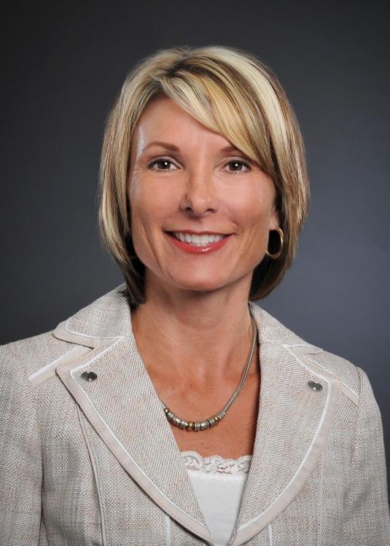
Sharon Hillstrom, President and CEO, Bradenton Area Economic Development Corporation

