NEWS RELEASE--Immediate Release
Contact: Kimberly Dale / 954-849-5304 / kdale@keiseruniversity.edu

Keiser University Center for Culinary Arts Accepted Into World Association of Chefs Societies Recognition of Quality Culinary Education
The Melbourne, Sarasota, and Tallahassee campuses have all earned the distinction

Melbourne, FL—June 2015— The World Association of Chefs Societies (WACS) has accepted Keiser University’s Center for Culinary Arts for inclusion in their Recognition of Quality Culinary Education Program.

A WACS Education Review Panel reviewed the evidence provided by the KU Center for Culinary Arts and determined the Melbourne, Sarasota, and Tallahassee campuses meet and in some cases exceed WACS Standards of Quality Culinary Education.

“For Keiser University to have achieved this distinction clearly demonstrates the quality of the culinary arts program we are offering to our students”, stated Joseph Hardiman, Associate Vice Chancellor of Culinary Arts.

WACS representatives made a plaque presentation at the Melbourne Center for Culinary Arts in front of community leaders and other distinguished guests. Similar events are being scheduled for the future at Sarasota and Tallahassee campuses.

Chef James McGuinness, Dean of Culinary Arts at Keiser University in Melbourne, described the benefit for his students beyond the international recognition that the campus has received with WACS, “Keiser University’s inclusion in this program will provide our students with a broader range of topics of concern to aspiring Culinarian’s and enhance their global perspective on food.”

Keiser University began offering the culinary arts program at the Tallahassee campus in 1998 and after 2003 was approved to begin the program at the Melbourne campus and Sarasota followed after 2005. Currently enrollment between the three campuses is close to 200. Keiser University Center for Culinary Arts is accredited by the American Culinary Federation. Its Associate of Science degree in Culinary Arts presents a comprehensive curriculum that includes laboratory sessions, academic preparation and hands-on experience. Students acquire professional knowledge of food, its preparation and handling and cooking from basic to advanced. The curriculum includes an externship to prepare students for entry-level positions in the foodservice industry.

About Keiser University: Keiser University is a private, not-for-profit University serving nearly 20,000 students offering 100 degrees at the doctoral through associate level on 17 Florida campuses, online and internationally, employing 3,500 staff and faculty. Keiser University holds Level VI accreditation signifying recognition of its expanded doctoral degree offerings.

Sixty-two percent of KU students graduate in STEM (Science, Technology, Engineering and Math) and healthcare fields, providing the talented workforce necessary for Florida to compete globally. Statewide Keiser University campuses currently have 60 accredited programs, spanning 21 program offerings, from 18 accrediting agencies/regulatory agencies to ensure that the top industry standards are met in degrees such as nursing, occupational therapy assistant, radiologic technology, physical therapy assistant, physician’s assistant, and many others.

Keiser University is accredited by the Southern Association of Colleges and Schools Commission on Colleges to award certificates and degrees at the associate, baccalaureate, masters, specialist, and doctoral levels. Contact the Commission on Colleges at 1866 Southern Lane, Decatur, Georgia 30033-4097 or call 404-679-4500 for questions about the accreditation of Keiser University.

For additional information regarding Keiser University, go to www.keiseruniversity.edu

###

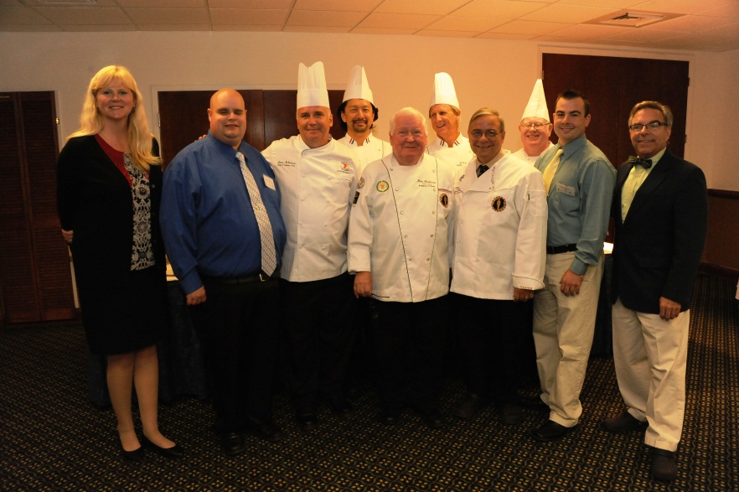
(left to right) KU Melbourne Campus President, Colleen Browne; KU Sarasota Dean of Culinary Arts, Michael Moench; KU Melbourne Dean of Culinary Arts, James McGuinness CCE; KU Melbourne Chef Instructor William Jung; Chef Klaus Friedenreich CMC; Hermann G. Rusch; KU Melbourne Chef Instructor, John Curtis; Chef Michael Baskette CEC CCE AAC; KU Lead Chef Presenter Chef Frank Lauterman; KU Sarasota Department Chair Baking and Pastry, Blake Ellis PCEC; KU Associate Vice Chancellor for Culinary Arts, Joseph Hardiman, HAAC

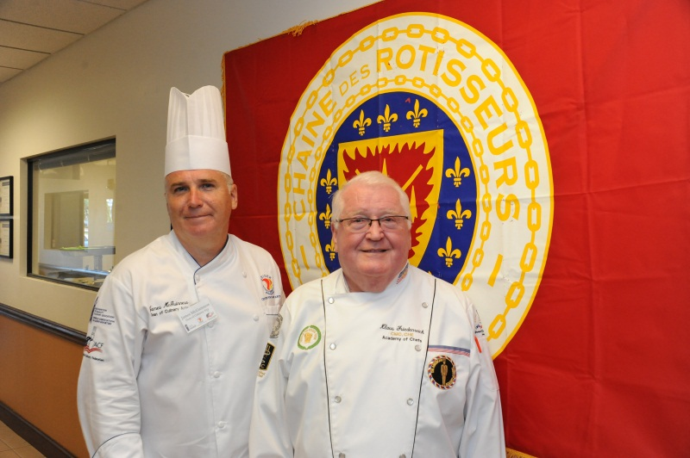
Dean of Culinary Arts, James McGuinness CCE and Chef Klaus Friedenreich CMC

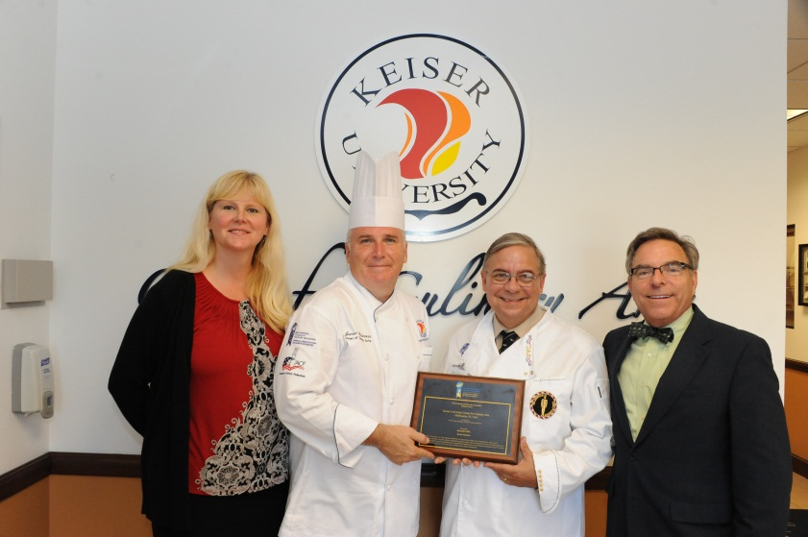
Colleen Browne KU Melbourne Campus President, Chef James McGuinness CCE, Dean of Culinary Arts, Chef Michael Baskette CEC CCE AAC, Assistant Continental Director for the Americas with the World Association of Chefs Societies (WACS) and Joseph Hardiman HAAC KU Associate Vice Chancellor for Culinary Arts

