**NEWS RELEASE--***Immediate Release*

Contact:  Kimberly Dale / 954-849-5304 / [kdale@keiseruniversity.edu](mailto:kdale@keiseruniversity.edu)

**Keiser University Center for Culinary Arts Announces Designation as the Chaîne des Rôtisseurs Regional Chef Training Facility at Keiser University**

*Honor bestowed by Chaîne des Rôtisseurs during dedication and ribbon cutting ceremony*

**Sarasota**, FL—June 2015— Keiser University’s Sarasota Center for Culinary Arts held a dedication and ribbon cutting ceremony for the student training kitchen designated as the *Chaîne des Rôtisseurs Regional Chef Training Facility at Keiser University*. The ceremony was held on Friday, May 29, 2015 and included the tradition of sabering a bottle of champagne, performed by the Southeast USA Bailli Provincial Dr. Charles Radlauer.

Aside from the members of the community who were inducted into the Chaîne, Dr. Arthur Keiser had the distinction of being inducted into the Chaîne as a Maître Hotelier.  Six members of the campus’s Student Culinary Arts Competition team were inducted as “Rôtisseurs”, which is the entry level for students of the Culinary Arts. Their names are Robin Neff, Lisa Tower, Maranda Howard, Renee Paul, Steven Fabaretti and Josh Agnew.  In addition, each student was recognized for their achievements as participants on the competition team. The students were awarded an achievement medal and a $250 scholarship from L’Academie Brillat-Savarin. The Brillat-Savarin is a discrete part of the Chaîne des Rôtisseurs which is dedicated to promoting education and enjoyment of fine food. Also two chef instructors and the campus president were inducted as Maître Rôtisseurs, they are Nicole Martinelli, Blake Ellis and Todd Cunningham respectively.

“This is an incredible distinction for Keiser University to be one of three Regional Chef Training Facilities in the United States and to serve as the prototype for the other two,” said Joseph Hardiman, Associate Vice Chancellor for Culinary Arts and Chaîne des Rôtisseur Vice Charge’ de Missions. The Chaîne des Rôtisseurs is the world’s oldest gastronomic society, founded in Paris in 1248. It is devoted to preserving the camaraderie and pleasures of the table and to promoting excellence in all areas of the hospitality arts.

After the ceremony, a five course meal with wine pairings for each course was served to the guests. The dinner was prepared by KU Sarasota Culinary Arts Student Competition Team members, fellow students, and chef instructors. The wine pairings were selected by a local Bailli Provincial member of the Chaîne des Rôtisseurs Southeast Region, Thomas Coundit.

“There are currently three facilities which have been given this very prestigious distinction: Kapiolani Community College in Hawaii, the Culinary Institute of Oregon, as well as Keiser University in Sarasota, Florida. We strongly felt it was appropriate since Keiser was the first approved site for this distinction that its official ribbon cutting ceremony was the first to be conducted. Congratulations to Keiser University for the enormous dedication to our industry, especially in supporting the Chaine des Rotisseurs,” stated Dr. Reimund D. Pitz CEC CCE AAC WCMC, CDR Consellier Culinaire et des Professionnels National, Chairman of ACF Culinary Committee, ACF Past National President.

Another recent accolade for Keiser University’s Culinary Arts program, the World Association of Chefs Societies (WACS) has accepted Keiser University’s Center for Culinary Arts for inclusion in their Recognition of Quality Culinary Education Program. A WACS Education Review Panel reviewed the evidence provided by the KU Center for Culinary Arts and determined the Melbourne, Sarasota, and Tallahassee campuses meet and in some cases exceed WACS Standards of Quality Culinary Education.

Keiser University began offering the culinary arts program at the Tallahassee campus in 1998 and expanded it to the Melbourne campus in 2004 and then to the Sarasota campus in 2005.  Currently enrollment between the three campuses is close to 200.  Keiser University Center for Culinary Arts is accredited by the American Culinary Federation Educational Foundation. Its Associate of Science degree in Culinary Arts presents a comprehensive curriculum that includes laboratory sessions, academic preparation and hands-on experience. Students acquire professional knowledge of food, its preparation and handling and cooking from basic to advanced. The curriculum includes an externship to prepare students for entry-level positions in the foodservice industry.

**About Keiser University:** Keiser University is a private, not-for-profit University serving nearly 20,000 students offering 100 degrees at the doctoral through associate level on 17 Florida campuses, online and internationally, employing 3,500 staff and faculty. Keiser University holds Level VI accreditation signifying recognition of its expanded doctoral degree offerings.

Sixty-two percent of KU students graduate in STEM (Science, Technology, Engineering and Math) and healthcare fields, providing the talented workforce necessary for Florida to compete globally. Statewide Keiser University campuses currently have 60 accredited programs, spanning 21 program offerings, from 18 accrediting agencies/regulatory agencies to ensure that the top industry standards are met in degrees such as nursing, occupational therapy assistant, radiologic technology, physical therapy assistant, physician’s assistant, and many others.

Keiser University is accredited by the Southern Association of Colleges and Schools Commission on Colleges to award certificates and degrees at the associate, baccalaureate, masters, specialist, and doctoral levels.  Contact the Commission on Colleges at 1866 Southern Lane, Decatur, Georgia 30033-4097 or call 404-679-4500 for questions about the accreditation of Keiser University.

For additional information regarding Keiser University, go to [www.keiseruniversity.edu](http://www.keiseruniversity.edu)

###

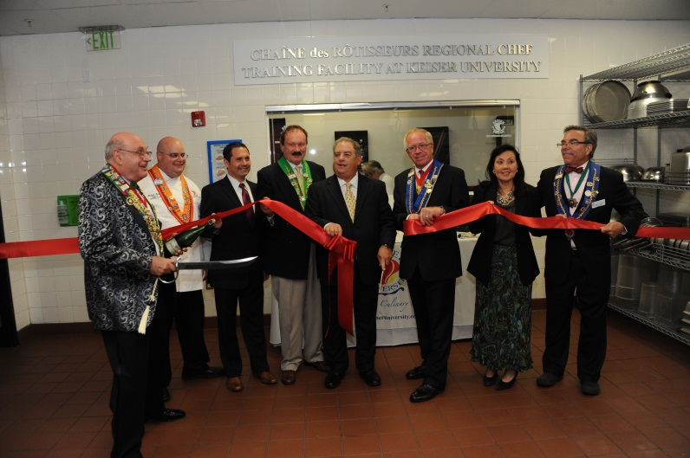

The Ribbon Cutting for the Chaîne des Rôtisseurs Regional Chef Training Facility at Keiser University

(L to R) - Chaîne des Rôtisseur Southeast USA Bailli Provincial, Charles Radlauer; Sarasota Dean of Culinary Arts, Michael Moench; Sarasota Campus President, Todd Cunningham; Chaîne des Rôtisseurs Sarasota Bailli, Tom Coundit; Chancellor, Dr. Arthur Keiser; Chaîne des Rôtisseurs Conseiller Culinaire et des Professionnels National, Dr. Reimund D. Pitz CEC CCE AAC WCMC; Vice Chancellor of Community Relations and Student Advancement, Belinda Keiser; Associate Vice Chancellor for Culinary Arts, Joseph Hardiman HAAC, Chaîne des Rôtisseurs Vice Charge’ de Missions Orlando Bailliage

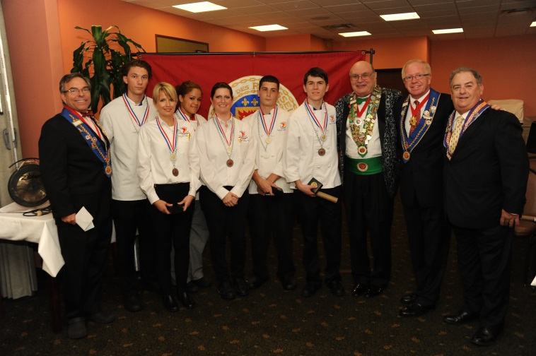

Students from The Keiser University Sarasota Student Culinary Arts Competition Team who were inducted into the Chaîne des Rôtisseurs, also each was awarded an Achievement Medal from the L’Academie Brillat-Savarin and a $250 scholarship

(L to R) - Associate Vice Chancellor for Culinary Arts, Joseph Hardiman HAAC, Chaîne des Rôtisseurs Vice Charge’ de Missions Orlando Bailliage; Students: Robin Neff, Lisa Tower, Maranda Howard,Renee Paul

Steven Fabaretti, Josh Agnew; Chaîne des Rôtisseur Southeast USA Bailli Provincial, Charles Radlauer;

Chaîne des Rôtisseurs Conseiller Culinaire et des Professionnels National, Dr. Reimund D. Pitz CEC CCE AAC WCMC; Chancellor, Dr. Arthur Keiser

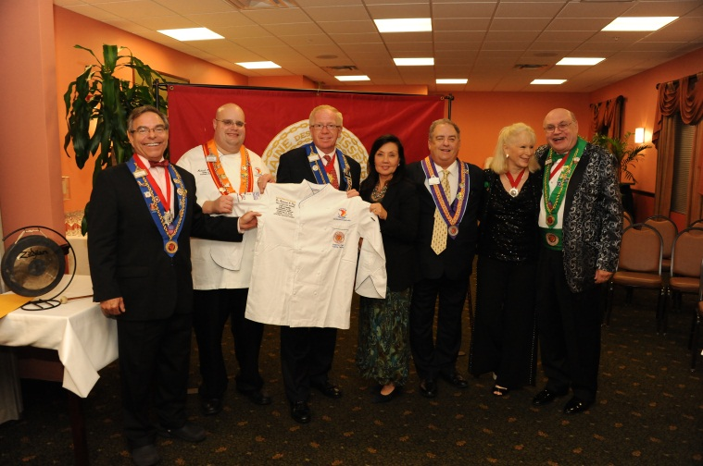

Presentation to Chef Pitz of the first “Special Friend of the University” Chef’s jacket. A copy of which will be has been signed by all guests and will be displayed in the campus with this picture

(L to R) - Associate Vice Chancellor for Culinary Arts, Joseph Hardiman HAAC, Chaîne des Rôtisseurs Vice Charge’ de Missions Orlando Bailliage; Sarasota Dean of Culinary Arts, Michael Moench; Chaîne des Rôtisseurs Conseiller Culinaire et des Professionnels National, Dr. Reimund D. Pitz CEC CCE AAC WCMC;

Vice Chancellor of Community Relations and Student Advancement, Belinda Keiser; Chancellor, Dr. Arthur Keiser; Chaîne des Rôtisseurs Miami Bailli, Nancy Radlauer; Chaîne des Rôtisseurs Southeastern (USA) Bailli Provincial ,Charles Radlauer

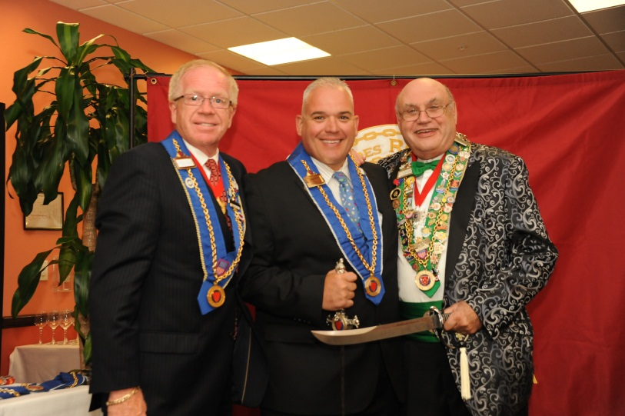

Chaîne des Rôtisseurs Conseiller Culinaire et des Professionnels National, Dr. Reimund D. Pitz CEC CCE AAC WCMC; Chaîne des Rôtisseur Southeast Conseiller Culinaire, Rene Marquis CEC CCE CCA AAC;

Chaîne des Rôtisseur Southeast USA Bailli Provincial, Charles Radlauer

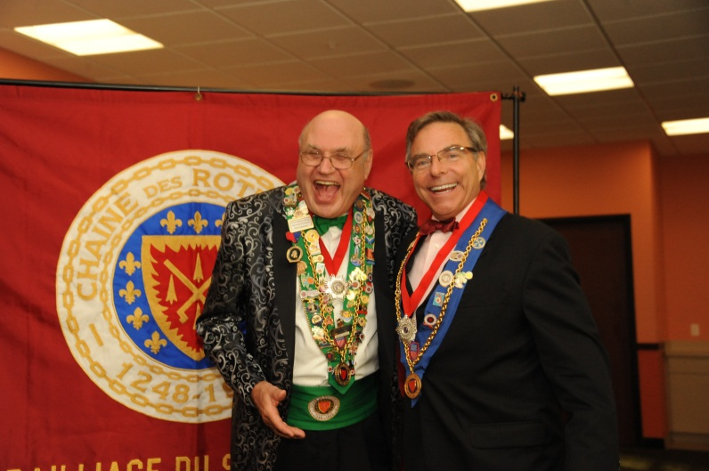

Chaîne des Rôtisseur Southeast USA Bailli Provincial, Charles Radlauer and Keiser University Associate Vice Chancellor for Culinary Arts, Joseph Hardiman HAAC, Chaîne des Rôtisseurs Vice Charge’ de Missions after Hardiman was presented with the Silver Star