NEWS RELEASE--Immediate Release
Contact: Kimberly Dale / 954-849-5304 / kdale@keiseruniversity.edu

Keiser University Students Attend Society of Nuclear Medicine and Molecular
Imaging Annual Conference
This is the second year Keiser University students have been accepted to participate

Lakeland, FL—July 2015— Keiser University’s Lakeland campus had four Nuclear Medicine students present their student abstracts for the Society of Nuclear Medicine and Molecular Imaging (SNMMI) at their annual conference held from June 5-10, 2015 in Baltimore, Maryland.

The Lakeland students who made presentations were Brianne Burton (Comparative analysis of the advantages of F18-NaF PET/CT scans in place of Tc99m-MDP nuclear bone scans for detecting osseous metastases), Kenneth Danberry (The Effects of USP 797 on red blood cell tagging), Alana Jordan (The future of positron emission mammography [PEM] ), and Kristen Massey (Yttrium-90 radioembolization and the prolonged life expectancy of colorectal cancer patients).

“We are so proud that all four of the students who submitted an abstract were accepted to present them at the annual conference and were also granted a travel award from the SNMMI of $1,000 each,” said Rebecca McDonnell, Campus President.

The Society of Nuclear Medicine and Molecular Imaging is a nonprofit scientific and professional organization promoting the science, technology and practical application of nuclear medicine and molecular imaging. Worldwide, SNMMI has 18,000 members and represents nuclear and molecular imaging professionals who are committed to the advancement of the field.

The SNMMI annual meeting is the largest live conference in the nation representing Nuclear Medicine. At the conference, students had the opportunity to attend numerous educational symposiums and lectures, meet leaders and medical imaging professionals in the field of Nuclear Medicine from around the world, learn new developments and trends, and attend a comprehensive mock review for the national registry exam.

About Keiser University: Keiser University is a private, not-for-profit University serving nearly 20,000 students offering 100 degrees at the doctoral through associate level on 17 Florida campuses, online and internationally, employing 3,500 staff and faculty. Keiser University holds Level VI accreditation signifying recognition of its expanded doctoral degree offerings.

Sixty-two percent of KU students graduate in STEM (Science, Technology, Engineering and Math) and healthcare fields, providing the talented workforce necessary for Florida to compete globally. Statewide Keiser University campuses currently have 60 accredited programs, spanning 21 program offerings, from 18 accrediting agencies/regulatory agencies to ensure that the top industry standards are met in degrees such as nursing, occupational therapy assistant, radiologic technology, physical therapy assistant, physician’s assistant, and many others.

Keiser University is accredited by the Southern Association of Colleges and Schools Commission on Colleges to award certificates and degrees at the associate, baccalaureate, masters, specialist, and doctoral levels. Contact the Commission on Colleges at 1866 Southern Lane, Decatur, Georgia 30033-4097 or call 404-679-4500 for questions about the accreditation of Keiser University.

For additional information regarding Keiser University, go to www.keiseruniversity.edu

###

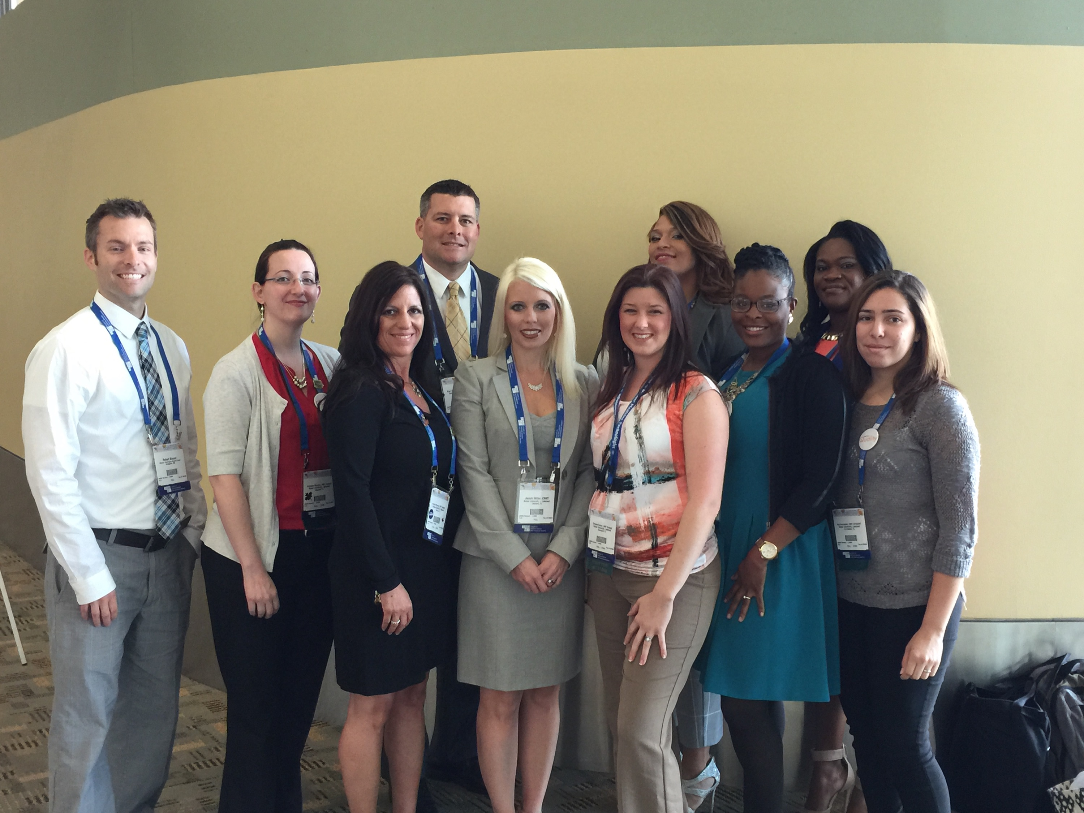
Left to right: Rob Blosser (Clinical Coordinator), Christine Mendes, Kristen Massey, Kenneth Danberry, Jasmin Miller (Program Director), Brianne Burton, Alana Jordan, Jessica Reese, Corhonda McLeod, and Ana Hernandez

