NEWS RELEASE--Immediate Release
Contact: Kimberly Dale / 954-849-5304 / kdale@keiseruniversity.edu

Keiser University Announces Results form 2015 HOSA
National Leadership Convention
All five students achieved top ten status for the entire nation

Port St. Lucie, FL—July 2015— Keiser University (KU) had five students attend the 2015 HOSA National Leadership Convention from June 23-28, 2015 in Anaheim California. There were 8,500 participants from around the nation who had made it past the state level to compete.

This year, KU Port St. Lucie took four students to nationals: Lala Stoller (Medical Photography), Elizabeth Roper (Extemporaneous Health Poster; Healthcare Issues Exam), Francesca Maglione (KT Nutrition), Nicole Klein (Persuasive Researched Speaking). KU West Palm Beach had one student: Angelica Jaramillo (Medical Photography). Two medals were won by KU students: Diet and Nutrition major, Francesca Maglione, took the first place medal for the Nutrition Knowledge category and Medical Assisting student, Liz Roper, took the third place medal for the Extemporaneous Health category. Nicole Klein and Lala Stoller were recognized for achieving top ten status in the nation.

“To clarify the enormity of this accomplishment for these five students, there were more than 150,000 competitors at combined regional and state levels nationwide, not including the 8,500 they went up against at the national level,” said Helen Mills, RN, MSN, AHI, faculty member and HOSA advisor. “We are proud of all of the Keiser students that participated in HOSA and look forward to another year of success and accomplishments.”

HOSA stands for Health Occupations Students of America and has a primary mission “to enhance the delivery of compassionate, quality health care by providing opportunities for knowledge, skill and leadership development of all health science education students, therefore, helping the student meet the needs of the health care community.” Their mission is accomplished through a series of testing and competitions, meant to encourage higher level learning and to foster healthy relationships in the process.

The event included concert-like gatherings with inspirational speakers, educational symposiums, exhibits presented by professional healthcare associations, business meetings, workshops, competitive events, social learning activities and opportunities to network with like-minded students around the nation and even across the globe.

About Keiser University: Keiser University is a private, not-for-profit University serving nearly 20,000 students offering 100 degrees at the doctoral through associate level on 17 Florida campuses, online and internationally, employing 3,500 staff and faculty. Keiser University holds Level VI accreditation signifying recognition of its expanded doctoral degree offerings.

Sixty-two percent of KU students graduate in STEM (Science, Technology, Engineering and Math) and healthcare fields, providing the talented workforce necessary for Florida to compete globally. Statewide Keiser University campuses currently have 60 accredited programs, spanning 21 program offerings, from 18 accrediting agencies/regulatory agencies to ensure that the top industry standards are met in degrees such as nursing, occupational therapy assistant, radiologic technology, physical therapy assistant, physician’s assistant, and many others.

Keiser University is accredited by the Southern Association of Colleges and Schools Commission on Colleges to award certificates and degrees at the associate, baccalaureate, masters, specialist, and doctoral levels. Contact the Commission on Colleges at 1866 Southern Lane, Decatur, Georgia 30033-4097 or call 404-679-4500 for questions about the accreditation of Keiser University.

For additional information regarding Keiser University, go to www.keiseruniversity.edu

###

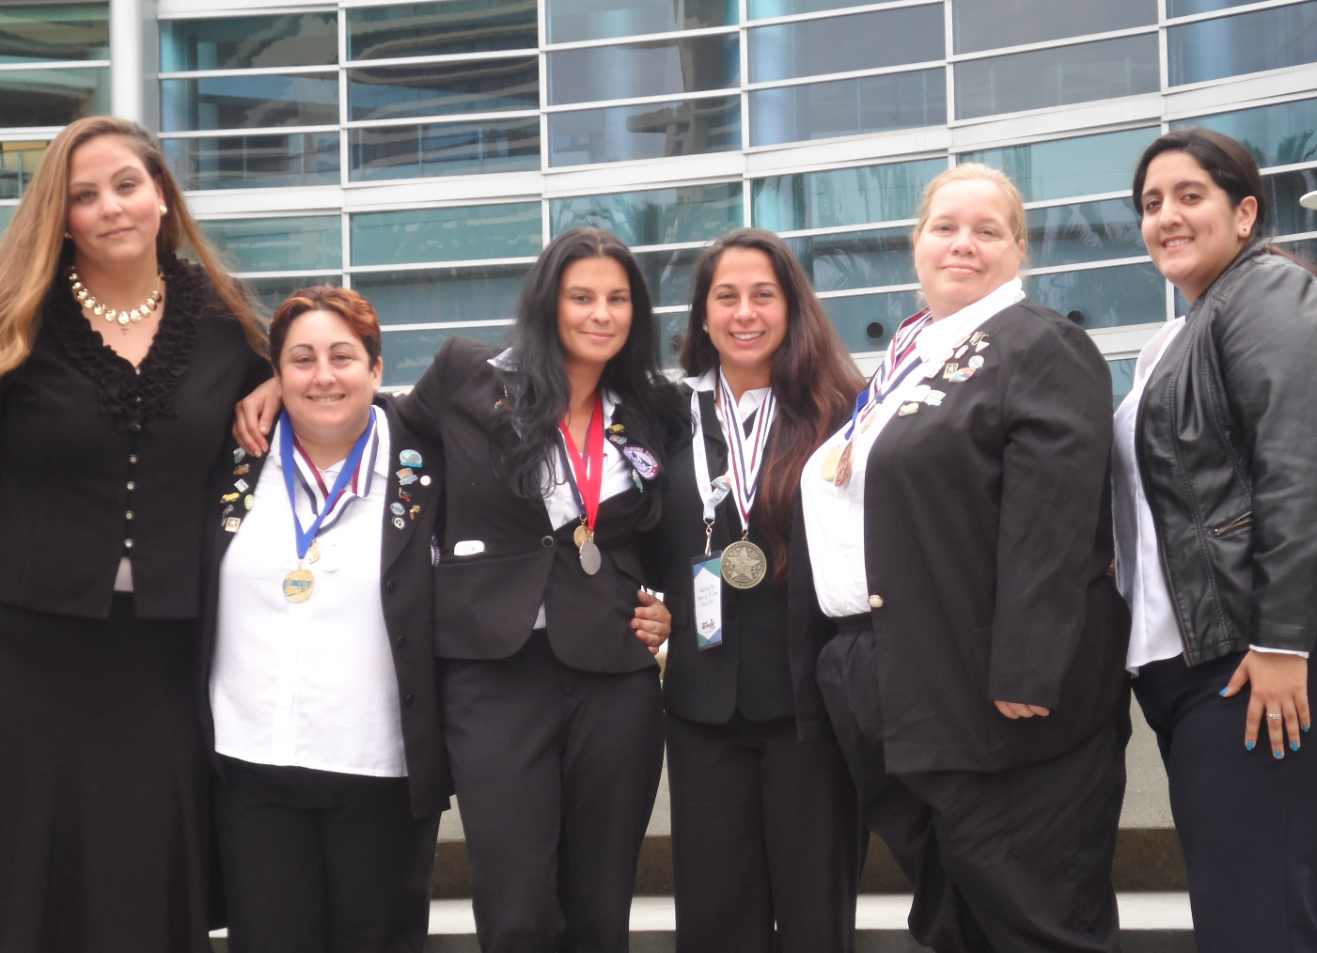
Left to right: Helen Mills, Lala Stoller, Nicole Klein, Francesca Maglione, Elizabeth Roper, Angelica Jaramillo

