For Immediate Release
Media Contact: Kimberly Dale / 954-849-5304 / kdale@keiseruniversity.edu

Keiser University Dean of Culinary Arts Participates
in “Rapid Fire” Chef’s Challenge
Four other chefs from around the state also competed at the Florida Restaurant and Lodging Show

Melbourne, FL—October 2015— Chef James McGuinness, Dean at Keiser University’s Center for Culinary Arts in Melbourne, participated in the Ferdinand Metz Food Service Forum “Rapid Fire” Chefs Challenge at the Florida Restaurant and Lodging Show where he took the top prize.

Each chef was given a "mystery basket" of ingredients in addition to all of the items in a common kitchen. They were given 25 minutes to evaluate their items and produce three portions of an entree for evaluation by the panel of judges. The panel consisted of Chefs Perrotte and Pitz and one participant who was selected from the audience by the event Master of Ceremonies Joseph Hardiman HAAC MBA CHA. The competitors were evaluated on flavor, presentation and completion on time.

“It was exciting to go head to head against these talented chefs and I am pleased the judges selected my dish as their favorite. My dish was peppered beef sirloin caps with a three vinegar syrup, pommes fondant, melted leeks, cremini mushrooms and parsley garlic jus,” said Chef James McGuinness, Dean at Keiser University’s Center for Culinary Arts. Chef McGuinness has been with Keiser University for five years. He began his career as an ACF Apprentice at the Westin Hotel, Chicago and has worked in a variety of positions in the Hospitality Industry including time at the Four Seasons, Chicago, as a consultant to Kraft and Sara Lee Foods and as a Culinary Instructor at St. Augustine College and Le Cordon Bleu, Chicago.

The competitors aside from Chef McGuinness included Hari Palapaka, Chef and Co-owner of Cress restaurant in Deland, Chef Richard Deivert, Keiser University Sarasota, and Chef Elizabeth Kublasingh and Eric Diaz from Le Cordon Bleu in Orlando. As the winner of this competition Chef McGuinness has earned the right to be one of the judges at next year's competition.

"Chef McGuinness produced the best flavor and plate presentation, and also demonstrated the most poise on stage with his knowledgeable and friendly banter with the audience as he produced his entree," according to Chef Pitz.

About Keiser University: Keiser University is a private, not-for-profit University serving nearly 20,000 students offering 100 degrees at the doctoral through associate level on 18 Florida campuses, online and internationally, employing 3,500 staff and faculty.

Sixty-two percent of KU students graduate in STEM (Science, Technology, Engineering and Math) and healthcare fields, providing the talented workforce necessary for Florida to compete globally.

Keiser University is accredited by the Southern Association of Colleges and Schools Commission on Colleges to award certificates and degrees at the associate, baccalaureate, masters, specialist, and

doctoral levels. Contact the Commission on Colleges at 1866 Southern Lane, Decatur, Georgia 30033-4097 or call 404-679-4500 for questions about the accreditation of Keiser University.

For additional information regarding Keiser University, go to www.keiseruniversity.edu

###
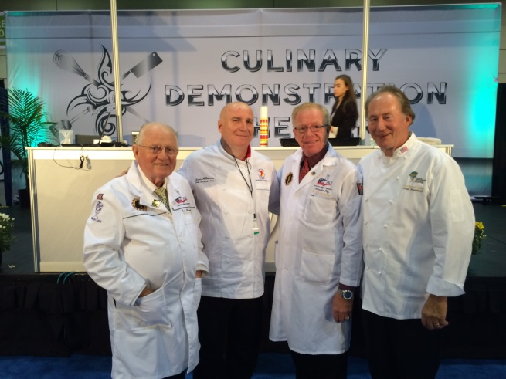
From Left to Right: Louise Perrotte, James McGuinness, Reimund Pitz, and Ferdinand Metz

