Keiser University’s First Annual Golf Classic with Jack Nicklaus Raises over $200,000

Media Contact: Kimberly Dale / 954-849-5304 / kdale@keiseruniversity.edu

West Palm Beach, FL—Nov. 25—On Nov. 20, athletes, coaches and elected officials joined Keiser University and Jack and Barbara Nicklaus for the University’s inaugural golf classic on The Champion Course at PGA National Resort and Spa. Well-known attendees included former Speaker of the House John Boehner, former Congressman Larry Smith, incoming Florida Senate President Joe Negron, and State Representative Ritch Workman; former Miami Dolphins Bob Griese, Rob Konrad, Sean Hill, Woody Bennett, Bryan Salter; former University of Miami and Florida Atlantic University head football coach Howard Schnellenberger; professional football players Lionel Dalton, Ray Crittenden, Patrick Dennis, and Eric Robinson; hockey legend Bobby Orr; baseball greats Michael Charles Brantley, Michael “Mickey” Brantley, Scott Proctor, Jake Johansen; and basketball stars Billy Cunningham, and Coach Rollie Massimino, who is the national championship coach of Villanova’s winning team in 1985, and current head men’s basketball at Keiser University.

Over 100 participants participated in the event which raised over $200,000.00 for both the Nicklaus Children’s Health Care Foundation and Keiser University’s Keiser Mills Foundation for student scholarships.

Keiser University Vice Chancellor Belinda Keiser recognized Jack and Barbara Nicklaus for the outstanding work on behalf of children and families across Florida. For the success of the event, she credited all of the sponsors and underwriters acknowledging the major sponsors as Iontuition, Becker Media, Keypath Education, Oasis Outsourcing, Saxon Business Systems, ESPN West Palm Beach, and many other generous members of the business community.

Hosting a golf tournament for the charities was the perfect fit. For the first time in Keiser University Seahawk history, the men’s golf team is ranked first in the National Association of Intercollegiate Athletics (NAIA) Coaches Poll, the current national champion women’s golf team remains ranked first in the NAIA Coaches Poll, and the University’s club golf team has qualified to compete at nationals as members of the National Collegiate Club Golf Association.

###

Keiser University is a private, not-for-profit university serving nearly 20,000 students offering 100 degrees at the doctoral through associate level on 18 Florida campuses, online and internationally, employing 3,500 staff and faculty.

The Flagship Campus of Keiser University is located at 2600 North Military Trail in West Palm Beach

Keiser University is accredited by the Southern Association of Colleges and Schools Commission on Colleges to award certificates and degrees at the associate, baccalaureate, masters, specialist, and doctoral levels. Contact the Commission on Colleges at 1866 Southern Lane, Decatur, Georgia 30033-4097 or call 404-679-4500 for questions about the accreditation of Keiser University.

For additional information regarding Keiser University, go to www.keiseruniversity.edu

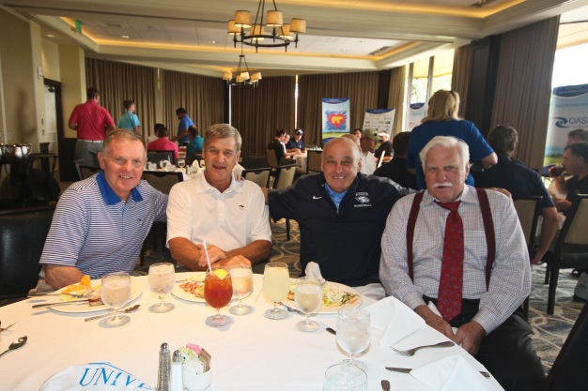
Left to right: Bob Griese, Bobby Orr, Rollie Massimino, Howard Schnellenberger

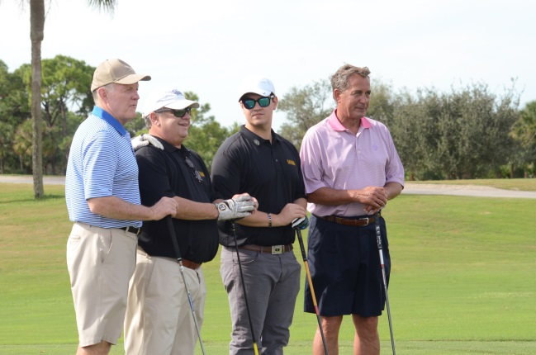
Left to right: Bob Griese, Dr. Art Keiser, Robert Keiser, Fmr. Speaker John Boehner

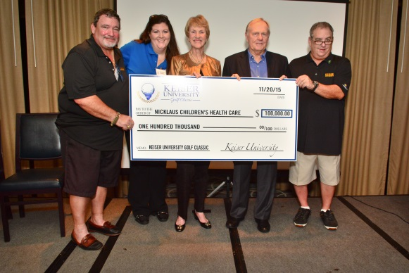
Left to right: Peter Crocitto, Dr. Melissa Gerdes, Barbara Nicklaus, Jack Nicklaus, Dr. Art Keiser

