

News Release--For Immediate Release

Media Contact: Kimberly Dale / 954-849-5304 / [kdale@keiseruniversity.edu](mailto:kdale@keiseruniversity.edu)

**Keiser University Signs Joshua Harriott to the Inaugural Men’s Swim Team**

*Keiser University’s Coach Adam Epstein recruited him from SW Florida Christian Academy*

**Ft. Myers, FL**– Aug. 2016— Keiser University recently signed Southwest Christian Academy’s Joshua Harriott as the 13th member of the men’s inaugural recruiting class for men’s swimming. He will begin the fall semester at the [Flagship campus](http://www.keiseruniversity.edu/residential/), located at 2600 North Military Trail in West Palm Beach, in September of 2016.

“Josh is the hard-working, great kid that every coach strives to find,” stated Joshua Epstein, Men’s and Women’s Swimming Coach at the Flagship campus. “I am very excited to have him join our team with his extensive range from middle distance free, to fly, to IM. He has the potential to come in and score at Nationals in multiple events. I cannot wait to see how he develops over the next four years.”

Keiser University has expanded its slate of varsity athletic programs for the 2016-17 academic year by adding men’s and women’s lacrosse, and men’s and women’s swimming. Adding these sports will bring the total number of varsity teams on campus to 20. Keiser University will begin the inaugural season for men and women’s swimming in the fall of 2016 at the All-Florida Invitational against Nova Southeastern. The NAIA swimming and diving championships consist of 20 events for men and 20 events for women. In swimming there are 26 schools that sponsor men’s programs and 29 that sponsor women’s programs.

When asked why he chose to be a part of Seahawk Nation Harriott said, “I chose Keiser University because of the many opportunities the university has for me. The environment, the size of the university, and class sizes are perfect and will help me stay focused so I can achieve my goals.”

The 100-acre, residential Flagship campus extends Keiser University’s educational offerings to over 100 degrees within the heart of South Florida. In addition to its well-recognized history of educating adult learners, a comprehensive college experience is available for traditional students seeking dormitories, and a culturally-rich campus-life comprised of students from a variety of international locations, athletics teams, and a safe environment to live, learn, work, and play. Learning and social activities are collaborative at Keiser University’s Flagship campus and involve present and future students, community partners, industry leaders, elected officials, and other constituents committed to the success of students. Throughout Florida and beyond, “Seahawk Nation” rallies behind the winning tradition of its 20 athletic teams.

Harriott followed up to add, “I’m excited to be making history by being a part of Keiser University’s inaugural swim team and Coach Epstein is a great coach who will help me reach my goals and take my swimming to the next level.”

###

**About Keiser University:** Keiser University, co-founded by Dr. Arthur Keiser, Chancellor in 1977, is a private, not-for-profit University serving nearly 20,000 students offering 100 degrees at the doctoral through associate level on 17 Florida campuses, online and internationally, employing 3,800 staff and faculty.

Keiser University is accredited by the Southern Association of Colleges and Schools Commission on Colleges to award certificates and degrees at the associate, baccalaureate, masters, specialist, and doctoral levels.  Contact the Southern Association of Colleges and Schools Commission on Colleges at 1866 Southern Lane, Decatur, Georgia 30033-4097 or call 404-679-4500 for questions about the accreditation of Keiser University.

For additional information regarding Keiser University, go to [www.keiseruniversity.edu](http://www.keiseruniversity.edu)

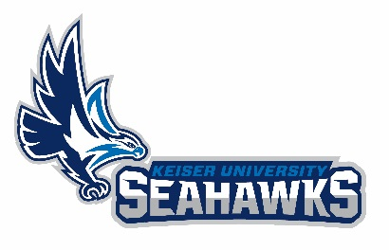

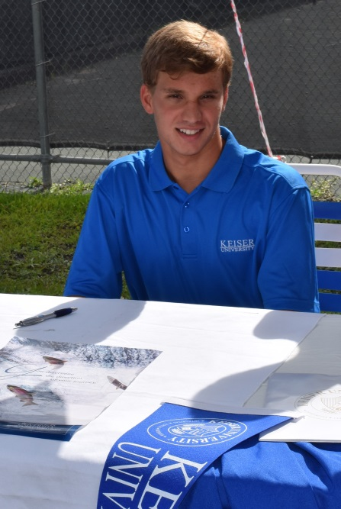

*Keiser University’s Flagship campus signed Joshua Harriott to the men’s inaugural recruiting class.*