

News Release--For Immediate Release

Media Contact: Kimberly Dale / 954-849-5304 / [kdale@keiseruniversity.edu](mailto:kdale@keiseruniversity.edu)

**Keiser University Student Recognized as UPS Scholar**

*Council of Independent Colleges-UPS Educational Endowment Fund awarded the scholarship to the Miami student*

**Miami, FL**– Aug. 17— The UPS Scholarship Award was recently awarded to **Michelle Vaquero**, a student at [Keiser University’s Miami campus](http://www.keiseruniversity.edu/miami/) who is earning her [Bachelor of Science degree in Imaging Sciences](http://www.keiseruniversity.edu/imaging-sciences-bs/). [The Council of Independent Colleges](http://www.cic.edu/Pages/default.aspx) (CIC) provided UPS Scholarships to 31 state associations, which distributed the funding to first-generation or low-income students at 585 private colleges and universities.

“It is satisfying to watch when our students are recognized for their dedication and commitment to earning degrees in fields that are vital to Florida’s diverse economy and global competitiveness,” said Dr. Arthur Keiser, Chancellor and CEO of Keiser University.

The UPS Scholarships are funded by the UPS Educational Endowment, which is held and administered by CIC. The Endowment was established in the 1970s by The UPS Foundation to support programs that benefit underserved populations. Since its inception, the Endowment has generated $54.5 million in scholarship support of 19,695 students at independent colleges and universities.

While working two jobs as a licensed nuclear medical technologist and taking care of her disabled husband who suffers from multiple sclerosis, Vaquero is also pursuing her degree in Imaging Sciences and maintaining a 4.0gpa. She chose to come back and earn this degree to expand her knowledge of and to be more informed about the different aspects of her field. She was nominated for this award by a faculty member, the Dean of Academics, and the Financial Aid Director who submitted her name to the Independent Colleges and Universities of Florida for consideration to receive the $2,600 award.

“This scholarship will motivate me to continue to excel in my academic endeavors, in my professional career, and in my personal life,” stated Michelle Vaquero, BS in Imaging Sciences student at Keiser University and UPS Scholar. “Having earned this scholarship proves that hard work pays off and I want to inspire my peers to continue to push themselves to achieve great things.”

Prior to attending [Keiser University](http://www.keiseruniversity.edu), Vaquero earned her Associate of Arts degree in Biology and her Associate of Science degree in Nuclear Medicine Technology (NMT), as well earning her NMT license.

The Miami campus, with a population of 900 students, will celebrate 15 years in the Miami area in October 2016. Since 2001 the campus has had more than 3,300 graduates in programs such as [Occupational Therapy Assistant](http://www.keiseruniversity.edu/occupational-therapy-assistant-as/), [Sports Medicine and Fitness Technology](http://www.keiseruniversity.edu/sports-medicine-and-fitness-technology-as/), and [Nursing](http://www.keiseruniversity.edu/nursing-as/).

###

**About Keiser University:** Keiser University, co-founded by Dr. Arthur Keiser, Chancellor in 1977, is a private, not-for-profit University serving nearly 20,000 students offering 100 degrees at the doctoral through associate level on 17 Florida campuses, online and internationally, employing 3,800 staff and faculty.

Keiser University is accredited by the Southern Association of Colleges and Schools Commission on Colleges to award certificates and degrees at the associate, baccalaureate, masters, specialist, and doctoral levels.  Contact the Southern Association of Colleges and Schools Commission on Colleges at 1866 Southern Lane, Decatur, Georgia 30033-4097 or call 404-679-4500 for questions about the accreditation of Keiser University.

For additional information regarding Keiser University, go to: www.keiseruniversity.edu



The **Council of Independent Colleges** is an association of 765 nonprofit independent colleges and universities and higher education affiliates and organizations that has worked since 1956 to support college and university leadership, advance institutional excellence, and enhance public understanding of private higher education’s contributions to society. CIC is the major national organization that focuses on providing services to leaders of independent colleges and universities as well as conferences, seminars, and other programs that help institutions to improve educational quality, administrative and financial performance, and institutional visibility. CIC conducts the largest annual conferences of college and university presidents and of chief academic officers. CIC also provides support to state fundraising associations that organize programs and generate contributions for private colleges and universities. The Council is headquartered at One Dupont Circle in Washington, DC.

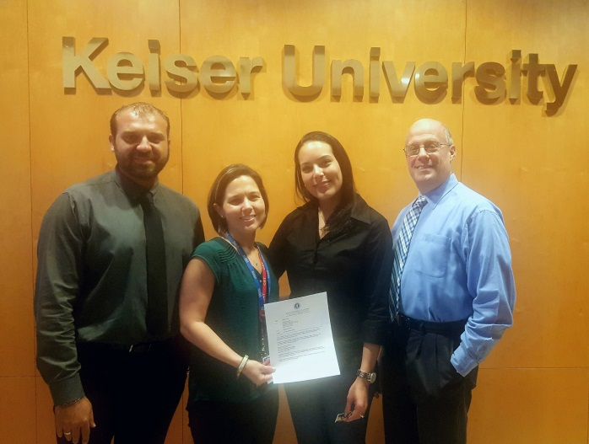

*Financial Aid Director Yanni Lapanaitis, Dean of Academics Dr. Cristy Sibila, and Campus President Dr. Gary Markowitz presenting KU Miami student Michelle Vaquero with her official letter recognizing her as the 2016-2017 UPS Scholar.*