**K E I S E R**

UNIVERSITY

For Immediate Release:

Media Contact: Suzi McCreery / 561-301-9583 / [smccreery@keiseruniversity.edu](mailto:smccreery@keiseruniversity.edu)

**Winner of Keiser University’s Pitch Competition Now Top Contender in**

**Richard Branson’s Virgin Media Business Contest**

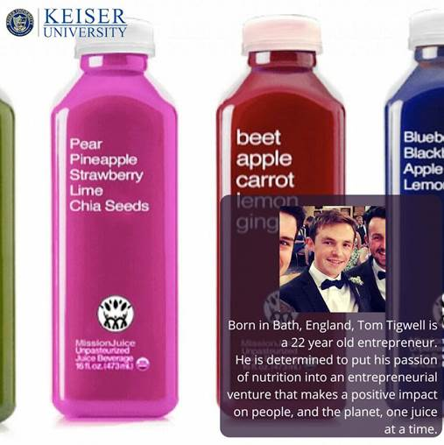

*The Keiser University student who won first place in the University’s Entrepreneurial Pitch Competition now ranks near the top of Richard Branson’s international Virgin Media Business: #VOOM 2016.*

Keiser University Entrepreneurship Society student Tom Tigwell was recently awarded $3,000 in Keiser University’s 1st Annual Entrepreneurial Pitch Competition, and today hopes to present to Richard Branson as he places near the top in Branson’s international Virgin Media Business: #VOOM 2016.

Billed as ‘the UK and Ireland's biggest and most valuable pitch competition,’ the 14-week contest will include a huge public vote, a 29-hour Pitchathon, a series of competitive face-to-face workshops and the big finale featuring Branson. For additional information relating to Tom and his product, please visit: <https://www.vmbvoom.com/pitches/mission-juice>

Mentored for the Keiser University contest under the guidance of Dr. Michael Olsher, Chair of Entrepreneurship and George Stamas, Professor of Entrepreneurship and Finance, the Keiser University Entrepreneurship Society was formed to bring students together to network in an environment where their entrepreneurial ideas and concepts for enterprise can be supported and accelerated, while providing the knowledge and skills necessary to help entrepreneurial dreams become a reality. “We are excited and proud to be a conduit for bringing our students new business ideas to life,” said Olsher, who is also a serial entrepreneur, and a former operating executive for major corporations and start-up businesses.

Keiser University Pitch Competition winners included:

1st Place: Mission Juice (Tom Tigwell) $3,000

2nd place: Stiles (Michael Parenti) $2,250

3rd place: Team Family International (Micaela Johansson, Alex Baguley) $1,500

4th place: Verbing (Mark Voisin) $1,250

5th place: Believa Cosmetics (Ross McPherson) $1,000

Honorable Mention: CONpro (Melissa Napolitano, Vivian Trujillo) VitaCard (Paal Johnsen) $250 each

Courtesy of Las Olas Capital, the Keiser Mills Foundation, Angelo Banta Law Firm, Tristate Bank, and FirstCity Bank of Commerce, Keiser University’s young entrepreneurs were awarded $10,000 in prize money to assist in bringing their inventions and business ideas to life. Judges included Glen Carwell, Associate Academic Dean at Keiser University’s Port St. Lucie campus, Ron Gaither, President of FirstCity Bank of Commerce in North Palm Beach, and Brian Bastin, Keiser University Professor of Finance and Entrepreneurship.

In addition to providing students the opportunity to participate in entrepreneurial roundtables and pitch competitions, the Keiser University Entrepreneurship Society offers business support, mentoring opportunities, workshops, and training opportunities that focus on intellectual property rights, and more. “This competition is a wonderful opportunity for our students to participate in the entrepreneurial process as they prepare for their future business opportunities,” added Stamas, who has also served as a former Wall Street banker and entrepreneur.

Founded by two entrepreneurs 40 years ago, Keiser University highly encourages students and graduates to launch their own companies while being of service and leadership in their communities.  Recently Belinda Keiser, Vice Chancellor of Keiser University, announced the launch of a Center for Entrepreneurship and Innovation at the Flagship Campus. The Center is intended to prepare graduates for entrepreneurship and to reach greater heights in their chosen professions, as many alumni already have.

Keiser University is a private, not-for-profit University. It serves nearly 20,000 students, offers approximately 100 degrees at the doctoral through associate levels on 18 Florida campuses, online and internationally, and employs 3,800 staff and faculty. Keiser University holds Level VI accreditation signifying recognition of its expanded doctoral degree offerings.

Keiser University is accredited by the Southern Association of Colleges and Schools Commission on Colleges to award certificates and degrees at the associate, baccalaureate, masters, specialist, and doctoral levels. Contact the Commission on Colleges at 1866 Southern Lane, Decatur, Georgia 30033-4097 or call 404-679-4500 for questions about the accreditation of Keiser University. For more information about us, please visit <http://www.keiseruniversity.edu>