NEWS RELEASE – Immediate Release
Contact: Kimberly Dale / 954-849-5304 / kdale@keiseruniversity.edu

Belinda Keiser Presents Scholarships at 13th Annual “Linking Women to Learning” Scholarship Luncheon
Two of the twelve students receiving scholarships are attending Keiser University

West Palm Beach, FL—June 21, 2016 — Keiser University was a proud participant at the 13th Annual “Linking Women to Learning” Scholarship Luncheon hosted by the Women’s Chamber of Palm Beach County. Mrs. Belinda Keiser made opening remarks to the attendees where she discussed the importance of believing in yourself, never letting go of your dreams, embracing change, and overcoming adversity.

“The strength of organizations like the Women’s Chamber of Palm Beach County is their dedication in guiding, supporting, and recognizing women in the community as leaders in the local and global economies,” stated Mrs. Belinda Keiser, Vice Chancellor of Community Relations and Student Advancement. “The Women’s Chamber will continue to be a strong source for our future leaders because of their ongoing service and their commitment to mentoring each of the scholarship recipients.”

At the luncheon 12 scholarships were awarded, with two of the winners currently earning degrees at Keiser University, Melissa Napolitano for Entrepreneurship and Jennifer Brugger for Master’s in Psychology.

Melissa Napolitano, who grew up in Bastrop Texas is earning her degree in Entrepreneurship in an accelerated program and is maintaining a 3.7GPA. While working toward this effort, she balanced 19 credit hours per semester, two part-time jobs, participation on the university’s Cross Country team, and an internship with the Women’s Chamber of Commerce, all while maintaining status on the Dean’s List. Also an active member of Keiser University’s Entrepreneurship Society, a participant in its 2016 Annual Pitch Competition, the Treasurer for its International Club, and a Student Ambassador, Melissa was recently invited to participate in the Disney College Program in Orlando, Florida. Therefore, she will complete her fall semester online. Melissa eventually hopes to start her own business in either Florida or Texas.

Jennifer Brugger is a 35 year old mother of two, a wife and a full-time undergraduate student of psychology. After graduating with her bachelor’s degree, she will be continuing on with Keiser University to earn her Master’s degree. Her goal is to work at the Veteran’s Administration as they are overcrowded and underfunded. Men and women face life and death situations both foreign and domestics with soldiers coming back from high stress situations and are unable to successfully integrate back in to their home lives or even adjusting to civilian life. As the mother of two children under the age of 10, should either of them choose to join our military forces when they are able, she wants to know they will be taken care of in every sense of the word when they return from the front lines. It is not easy being a mom, a full-time student, a part-time worker, a wife and homeschooling one of our children. However, she knows that when she enters the workforce, she can make a difference by bridging the gap and bringing in more psychologists to the Veteran’s Administration.

“The students who received these scholarships are strongly encouraged to pursue their dreams, embrace change, conquer adversity by welcoming the detour as a new and exciting path, listening to their inner core, and ultimately serving and celebrating their achievements,” Keiser stated.

About Keiser University: Keiser University, co-founded by Dr. Arthur Keiser, Chancellor in 1977, is a private, not-for-profit University serving nearly 20,000 students offering 100 degrees at the doctoral through associate level on 18 Florida campuses, online and internationally, employing 3,800 staff and faculty. Keiser University and the Keiser Mills Foundation provide nearly $44 million annually in need-based and academic scholarships.

Keiser University is accredited by the Southern Association of Colleges and Schools Commission on Colleges to award certificates and degrees at the associate, baccalaureate, masters, specialist, and doctoral levels. Contact the Commission on Colleges at 1866 Southern Lane, Decatur, Georgia 30033-4097 or call 404-679-4500 for questions about the accreditation of Keiser University.

For additional information regarding Keiser University, go to www.keiseruniversity.edu
# # #

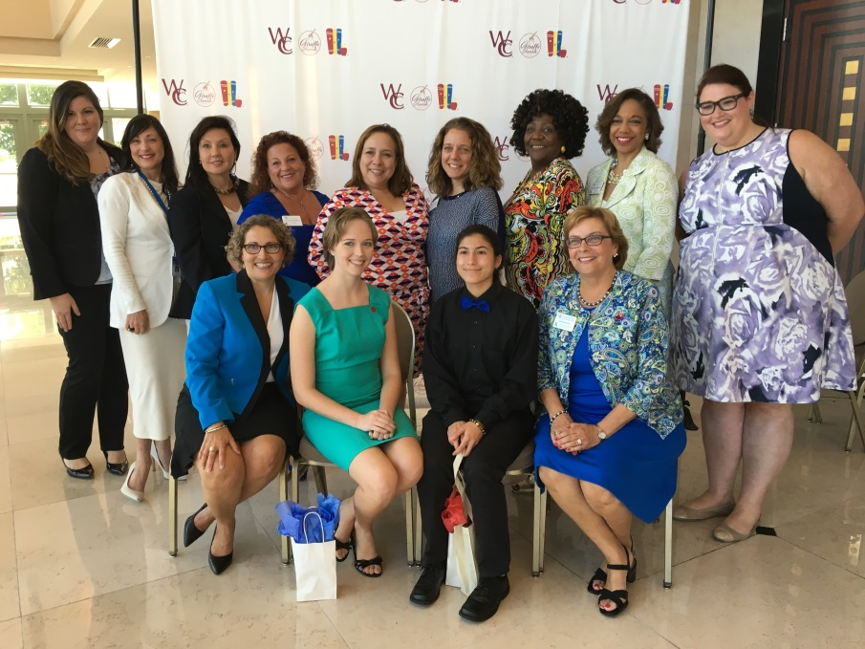
Belinda Keiser and representatives of Keiser University joined the board and staff of the Women’s Chamber of Palm Beach County to congratulate Melissa Napolitano (teal dress, first row), a Keiser student and scholarship recipient.

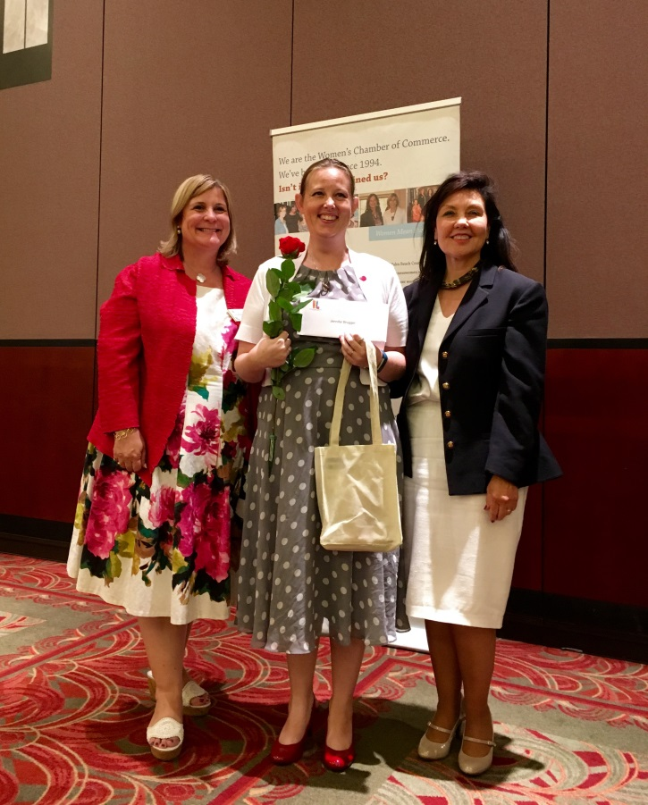
From left to right: Kimberly Lea, KU West Palm Beach Campus President; Jennifer Brugger, scholarship winner; Belinda Keiser, KU Vice Chancellor of Community Relations and Student Advancement

