NEWS RELEASE--Immediate Release
Contact: Kimberly Dale / 954-849-5304 / kdale@keiseruniversity.edu

Keiser University Orlando Faculty Member Receives National Recognition
Dr. Kyle Riding given leadership roles within two national associations

Orlando, FL—June 21, 2016—Keiser University is proud to announce the recent achievements of Dr. Kyle Riding, a Medical Laboratory Technology faculty member who has taken on a leadership role within two national associations for his field, the American Society for Clinical Laboratory Science (ASCLS) and the American Society for Clinical Pathology (ASCP).

“Keiser University has always taught the importance of leadership and serving the communities in which we live and work with this commitment extending beyond the classroom, as our students, faculty and staff continually seek opportunities to volunteer their time and resources,” stated Dr. Arthur Keiser, Chancellor and CEO of Keiser University.

Having been an active leader within the American Society for Clinical Laboratory Science for well over a decade, Dr. Riding is a respected member in the medical laboratory profession. He is currently serving as co-chair of a task force charged with rewriting the entry level curriculum for the profession, chair and facilitator of the 2016-2017 ASCLS Leadership Academy, and elected member of the association’s nominations committee.

He recently received an invitation from the American Society for Clinical Laboratory Science and the American Society for Clinical Pathology to collaboratively assess a newly created leadership development program for allied health professionals who seek to enhance their leadership skills.

“I am excited our Medical Laboratory Technician students have the opportunity to learn from an exceptional faculty member with such deep connections within his field,” stated Dr. David Hubbard, Campus President.

Dr. Riding earned his B.S. in Medical Laboratory Science from Umass Dartmouth in 2007 and his PhD in Public Health and Epidemiology from Walden University in 2013. He spent six years as a medical laboratory scientist and quality assurance specialist in the Department of Laboratory Medicine at Boston Children's Hospital. He also spent several years as a part-time and full-time lecturer at Umass Dartmouth along with serving as program director and chair of a Medical Laboratory Technician program at Quincy College. He currently serves as instructor of medical laboratory science at Keiser University's Orlando campus. Dr. Riding is actively involved at a variety of levels in the American Society for Clinical Laboratory Science (ASCLS) and served as President for the Central New England chapter of the organization prior to moving to Florida in 2015. He has received numerous awards for his work in the field and his service to the profession was honored in 2011 when he was inducted into the Alpha Mu Tau Honorary Fraternity. His research interests include using non-traditional classroom delivery models to increase MLT and MLS program capacity and the impact of federal regulations on the medical laboratory workforce.

About Keiser University: Keiser University, co-founded by Dr. Arthur Keiser, Chancellor in 1977, is a private, not-for-profit University serving nearly 20,000 students offering 100 degrees at the doctoral through associate level on 18 Florida campuses, online and internationally, employing 3,800 staff and faculty. Keiser University and the Keiser Mills Foundation provide nearly $44 million annually in need-based and academic scholarships.

Keiser University is accredited by the Southern Association of Colleges and Schools Commission on Colleges to award certificates and degrees at the associate, baccalaureate, masters, specialist, and doctoral levels. Contact the Commission on Colleges at 1866 Southern Lane, Decatur, Georgia 30033-4097 or call 404-679-4500 for questions about the accreditation of Keiser University.

For additional information regarding Keiser University, go to www.keiseruniversity.edu

# # #
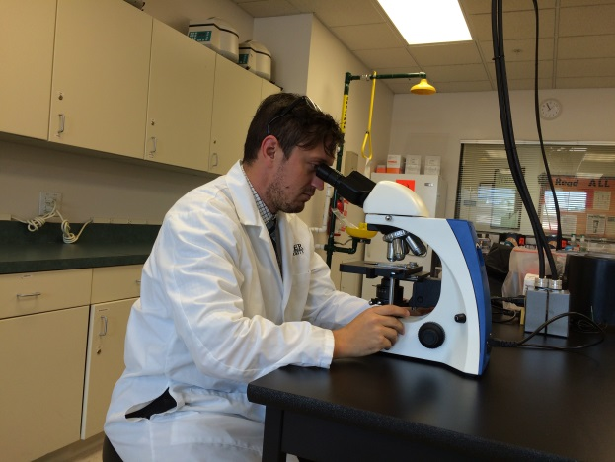
Dr. Kyle Riding, Medical Laboratory Technician faculty member

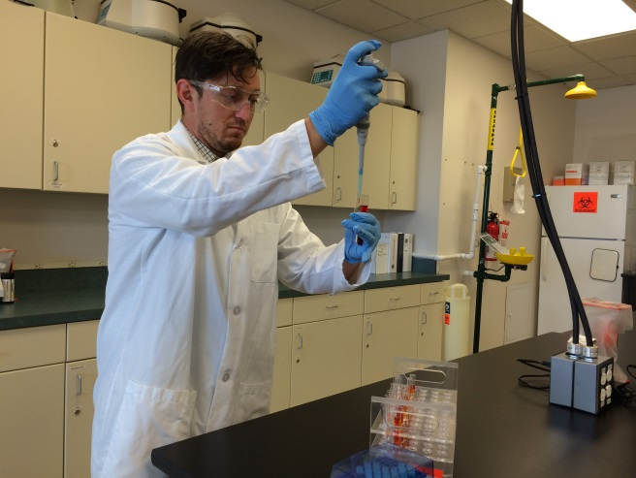
Dr. Kyle Riding works in the lab at Keiser University’s Orlando campus.
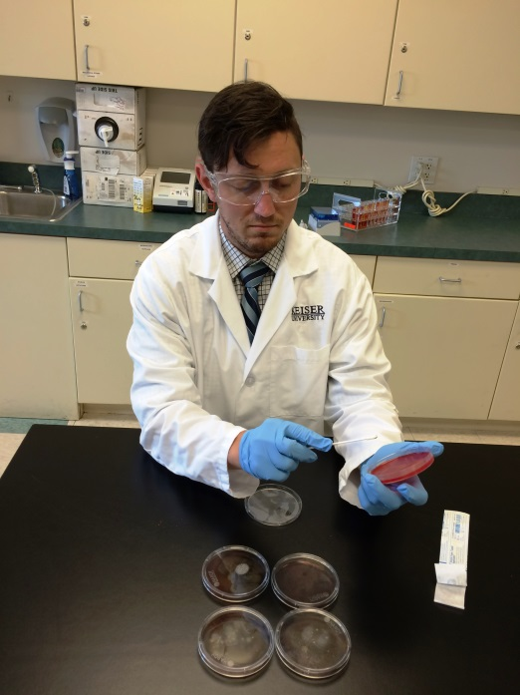
Dr. Kyle Riding works in the lab at Keiser University’s Orlando campus.

