

News Release--For Immediate Release

Media Contact: Kimberly Dale / 954-849-5304 / [kdale@keiseruniversity.edu](mailto:kdale@keiseruniversity.edu)

**Keiser University Occupational Therapy Assistant Program Receives a Donation from ABC Appliances & Services**

*Keiser University Tampa was gifted a washer and dryer to enhance learning opportunities*

*for OTA students*

**Tampa, FL**– Sept. 2016 — The [Occupational Therapy Assistant](http://www.keiseruniversity.edu/occupational-therapy-assistant-as/) (OTA) program at the [Tampa campus](http://www.keiseruniversity.edu/tampa/) of [Keiser University](http://www.keiseruniversity.edu), located at 5002 W. Waters Ave., was recently the recipient of a generous donation from ABC Appliances & Services of a washer and dryer.

This donation is meaningful to the program because the students will use the washer and dryer to simulate how to get the clothes in and out while having a disability. They may be using a walker or a wheelchair, which is very challenging. This will help the students learn what it may be like to help someone make adaptions in their home so they can independently do their own laundry.

“The Occupational Therapy Assistant program tries to focus on presenting scenarios in as much of a ‘real life’ experience as possible while in the classroom,” shared Stephanie Adams, MHS, OTR/L and OTA Program Director. “Empowerment is the key to success for an occupational therapist.”

The donation from ABC Appliances & Services resulted from two staff members from the KU Tampa campus who knew of the need and how it would benefit the students in their lab work, so they made the outreach effort on behalf of the program.

.

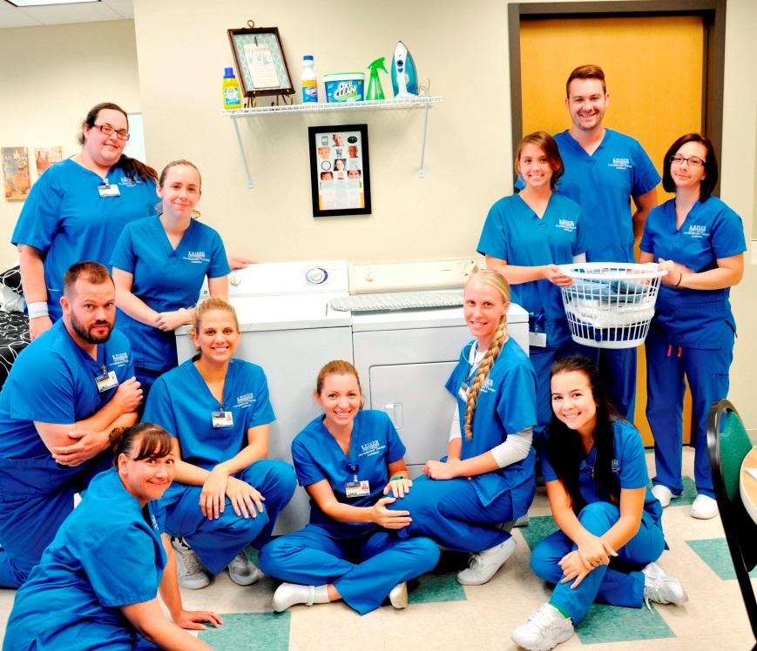

*The OTA class is extremely grateful to ABC Appliances & Services for the donation of the washer and dryer to the Tampa campus.*

###

**About Keiser University:** Keiser University, co-founded by Dr. Arthur Keiser, Chancellor in 1977, is a private, not-for-profit University serving nearly 20,000 students offering 100 degrees at the doctoral through associate level on 17 Florida campuses, online and internationally, employing 3,800 staff and faculty.

Keiser University is accredited by the Southern Association of Colleges and Schools Commission on Colleges to award certificates and degrees at the associate, baccalaureate, masters, specialist, and doctoral levels.  Contact the Southern Association of Colleges and Schools Commission on Colleges at 1866 Southern Lane, Decatur, Georgia 30033-4097 or call 404-679-4500 for questions about the accreditation of Keiser University.

For additional information regarding Keiser University, go to [www.keiseruniversity.edu](http://www.keiseruniversity.edu)

