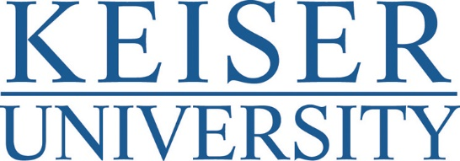

MEDIA ADVISORY - PHOTO OPPORTUNITY

Feb. 13, 2019
CONTACT: Dianne Anderson, 954-801-6538, danderson@keiseruniversity.edu

Keiser University Students Learn Lesson of the Heart on Valentine’s Day
Anatomy students spend the celebrated holiday of love learning life-saving techniques by dissecting a pig heart, which is strikingly similar to a human heart.
- Who: Professor Luis Fernandez and Students
- What: Heart Dissection on Valentine’s Day
- When: Thursday, February 14th 11 a.m. to 1 p.m.
- Where: Keiser University Tampa Campus
  - 5002 West Waters Avenue, Tampa, FL 33634, (813)885-4900

Was the human heart the inspiration for the traditional heart shape associated with Valentine’s Day? Philosophers from ancient days have long equated the human heart with the center of emotion. One theory is that over time, artists and illustrators simply took the shape of the human heart and made it more attractive. Whatever the source of the modern heart shape, today that shape represents love and strong emotion, which is appropriate, given how important the heart is to the human body.
Valentine’s day is also an appropriate time to take a deeper look at the heart, which is what Bio Medical students at Keiser University’s Tampa Campus will be doing this Thursday. In their Anatomy class, students will be learning more about the heart’s actual shape and function, as they perform a dissection of a pig heart, which is strikingly similar in size and structure to a human heart.
A pig heart consists of four chambers: two atriums and two ventricles. Likewise, consistent with the structure of a human heart, it has four valves and an aorta. In fact, pig hearts are so similar to human hearts that tissue from pig hearts is used to make heart valve replacements for humans.
Anatomy classes such as this one are part of the intensive one-month at a time classes that prepare Keiser students for their career fields. KU’s Bachelor of Science degree in Biomedical Sciences is a practical, pre-professional degree program designed to prepare students for admission to graduate programs in health care and biomedical science as well as professional schools for Medicine, Dentistry, Pharmacy, Physician Assistant, Occupational and Physical Therapy, and Veterinary Medicine.

About Keiser University:
Keiser University is a private, not-for-profit university, serving nearly 20,000 students and employing 3,800 faculty and staff members. Co-founded in 1977 by Chancellor Arthur Keiser, Ph.D., and Evelyn Keiser, the university currently offers more than 100 degrees at 21 Florida campuses, as well as online and at two international sites.
Keiser University is accredited by the Southern Association of Colleges and Schools Commission on Colleges as a level VI institution to award certificates and degrees at the associate, baccalaureate, masters, specialist, and doctoral levels.
For additional information regarding Keiser University, visit www.keiseruniversity.edu.

